Naturally, projects are not only limited to project managers, everybody executes projects daily in their sojourn through life. However, the nature of the project carried out by each individual is different from one another.
In Project Management, a project is a planned set of interrelated and sometimes dependent tasks that must be executed over a certain period of time taking into consideration certain costs, resources and other limitations. The task must be completed in order to reach a specific goal that will ultimately satisfy the need of a customer.
It can also be defined as a set of inputs and outputs needed to reach a specific outcome. However, your success as a project manager is dependent on how you can optimize the resources of a project and have it completed on time.
There are many different types of projects, reports to be filled out, different types of project meetings to be held, project management methodologies, they can be simple or complex and can be managed in various ways, all of which you will read about in this article.

TYPES OF PROJECTS IN PROJECT MANAGEMENT

You may be wondering what are the different types of projects? Or what is a Project in Project Management? What is Project Planning? Project management covers the management of projects and their running. Not all projects are the same and they vary on a number of different elements that make each project individually unique. These factors differ in projects and must be taken into consideration so that projects can be managed efficiently and effectively regarding each project type because of the variations in their sizes and structure.
Project scope: This describes the reach and scale of the project; it sets the tone of the success of a project. Also, it specifies the details of the work to be carried out in a project.
Project scope varies depending on the number of people involved and the scale of the impact of its outcomes. Projects can be big or small depending on the scope.
Timeframe: A project’s timeframe is defined from its initiation or conception until result evaluation. It is the period that a project is anticipated to be completed. A project’s timeframe can also be divided into smaller blocks which in themselves have their own timeframe.
Organisation: This is a key feature of effective project planning; ; the organisation of a project refers to how tasks and activities are organised and 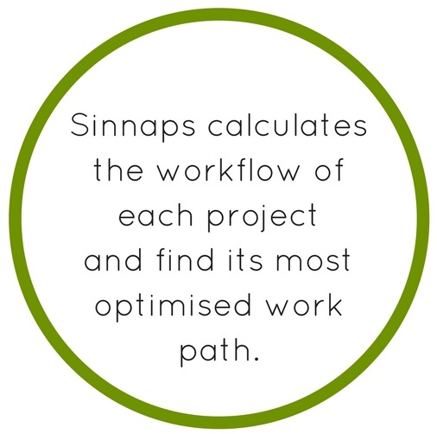prioritised. The project workflow is calculated in each project to reach the desired objectives. Sinnaps project management and planning tool uses technologies such as PERT and CPM to calculate the workflow of each project and find its most optimised work path along with various types of project management tools to ease the process of project execution.
Cost: Projects can be expensive or relatively cheap depending on their overall cost. The Sinnaps app allows you to plan your project costs along with any cost updates input by your team in real-time thereby allowing you to leave out no cost.
Communication: What are the types of projects that require communication? Communication is the cornerstone of every project. Among different types of projects, communication, its frequency and its format can vary. However, without effective communication, a project will fail. Effective communication is an essential tool that propels the success of any project irrespective of its size. Sinnaps allows the optimisation of communication through online real-time chat between team members and project managers thereby creating the right synergy between them.
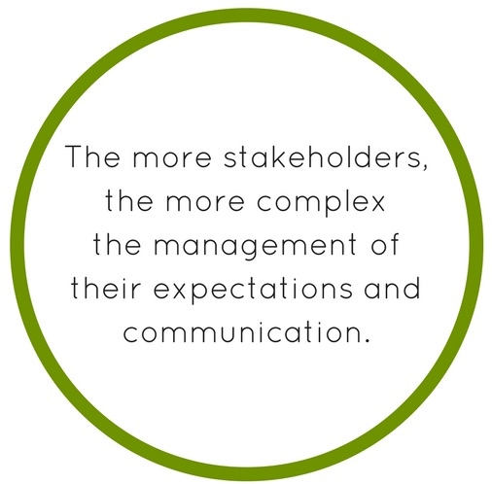Stakeholder Management: Projects can vary depending on the number of stakeholders involved. Sometimes, the only stakeholders involved in a project are the team and project manager, but more often than not, there are wider group of stakeholders involved. The more stakeholders, the more complex is the management of their expectations and communication. You can choose between these types of leadership.
Task assignation: Within the different types of projects in project management, there are many different tasks and activities. Projects can vary depending on how these tasks are assigned to team members- whether they will be completed by individual members or groups and how responsibilities will be defined. The onus is on the project manager to ensure that the tasks of the project are properly assigned to the right team members.
Quality of results: Results of projects vary among the different types of projects. They can vary depending on each client’s requests. No doubt, you should strive to deliver the right quality that meets or exceeds the expectations of the clients.

If you are interested, glance at this lesson…
What do these project types need?

CLASSIFICATION OF PROJECT

Every Project is different from one another. Projects can be classified based on several different points. The classification of projects in project management varies according to a number of different factors such as complexity, source of capital, its content, those involved and its purpose. Projects can be classified based on the following factors.

According to complexity:
- Easy: A project is classified as easy when the relationships between tasks are basic and detailed planning or organisations are not required. A small work team and a few external stakeholders and collaborators are common in this case. The tasks of the projects can be undertaken by a small team.
- Complicated: The project network is broad and complicated. There are many task interdependencies. With these projects, simplification where possible is everything. The task of executing this type of project requires proper planning. Cloud-based apps such as Sinnaps will immensely help to simplify complicated projects by automatically calculating the project’s best work path and updating any changes introduced through its use of different types of project management tools. Here, the importance of project management and how an effective tool could help you!

According to the source of capital:
- Public: Financing comes from Governmental institutions.
- Private: Financing comes from businesses or private incentives.
- Mixed: Financing comes from a mixed source of both public and private funding.

According to Project content:
- Construction: These are projects that have anything to do with the construction of civil or architectural work. Predictive methods are used along with agile techniques which will be explained later on. Furthermore, construction is an engineering project and the process of planning its execution must be painstakingly done to achieve the desired outcome.
- IT: Any project that has to do with software development, IT system, etc. The types of project management information systems vary across the board, but in today’s world are very common.
- Business: These projects are involved with the development of a business idea, management of a work team, cost management, etc., and they usually follow a commercial strategy.
- Service or product production: These are projects that involve the development of an innovative product or service, design of a new product, etc. They are often used in the R & D department.

According to those involved:
- Departmental: When a certain department or area of an organisation is involved.
- Internal: When a whole company itself is involved in the project’s development.
- Matriarchal: When there is a combination of departments involved.
- External: When a company outsources external project manager or teams to execute the project. This is common in digital transformations, process improvements and strategy changes, for example.

According to its objective:
- Production: Oriented at the production of a product or service taking into consideration a certain determined objective to be met by an organization.
- Social: Oriented at the improvement of the quality of life of people. This can be in the form of rendering corporate social responsibility (CSR) to the people.
- Educational: Oriented at the education of others. This is always done to make them better.
- Community: Oriented at people too, however with their involvement.
- Research: Oriented at innovation and the gaining of knowledge to enhance the operational efficiency of an organization.

TYPES OF PROJECT MANAGERS IN DIFFERENT TYPES OF PROJECTS

What is a project manager? Now that we know what a project is, the different types and its different classifications, we must consider the person responsible for bringing the goals of a project from the beginning to the end and that is the project manager. All types of projects in project management need a project manager. Like projects, there are different types of project managers. The burning question on everyone’s mind is how best to grow your organisation and how best to execute a project? Depending on the type of project a certain style of project manager will be best suited to execute the project properly.
The Prophet: This type of project manager focuses on grand opportunities. This manager relies on passionate team members that are extremely determined to comply with the vision of the project. Prophets are good for challenging an existing, possibly out-of-date strategy and seeking out new opportunities for growth that previously may have been overlooked.
The Gambler: This type of project manager actively pursues business opportunities that exist within the existing strategic boundaries of the business but are not being exploited to their full potential due to a lack of trustworthy data. Essentially, this project manager takes bets on growth opportunities. In a certain light, these managers can seem risky as the likelihood of success cannot be predicted. However, they are necessary to project management as they pursue certain overlooked opportunities that have potential that can enhance the growth of an organization.
The Expert: This type of project manager actively pursues business opportunities that lie outside the existing strategic boundaries, but contrary to the gambler and the prophet, opportunities for which there exists trustworthy data that carves a solid case. They love solid evidence that backs up their initiative to go with certain overlooked business growth opportunities. Their main challenge is to explain their vision and get everyone on the team on board while pursuing the goal.
The Executor: This project manager energetically pursues business opportunities that lie within the existing strategic boundaries and have a great case to be pursued. The sureness and confidence of this type of project manager are what gains trust from the other team members and followers of the project. Quantitative evidence is key for the executor and helps back up the pursuit of an opportunity.
Risk, uncertainty, and challenge are null. They simply excel at pinpointing opportunities that need to be sought after which are not currently. It is the most certain path to success. However, the executor lacks the ability to pinpoint more obscure and maybe riskier opportunities that could potentially be exploited.

