Bainbridge mass spectrometer:

K.T Bainbridge , an American Physicist designed an elegant instrument for the determination

of isotopic masses of element known as Bainbridge mass spectrometer.
Principle:
When a Uniform magnetic field acts normal to the path of ions ( or charges) having

same velocity, then it deflects the ions of different masses from a straight path to circular

paths of different radii.
A schematic diagram of this spectrometer is shown in Fig below.

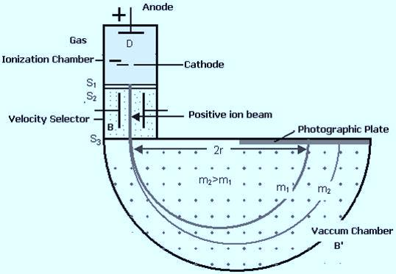

Construction:

(i)Ionization Chamber:

Ionization chamber is used to ionize the gas whose mass or isotopes are to be determined

and positive ions are produced in a discharge tube.
(ii) Velocity Selector:

Velocity selector has two fields electric and magnetic field both are applied perpendicular to

the moving ion beam. A potential is applied between two parallel plates to produce the

uniform electric field. A magnetic field B is applied at right angles to the electric field E in

such a way that the electric and magnetic forces acting on the ions act in the directions

opposite to each other.

(iii) Vacuum / Analyzing Chamber: Vacuum / Analyzing Chamber is a semi-

spherical cavity in which another magnetic field B' is applied perpendicular to the moving

positive ion.

Working:
A beam of positive ions produced in a discharge tube is collimated into a fine beam by two

narrow slits S1​and S2​. This fine beam enters into a velocity selector. The velocity selector

consists of two plane parallel plates ​, which produces a uniform electric field E and an

electromagnet, to produce uniform magnetic field B (represented by the dotted circle). The

velocity selector allows the ions with a particular velocity to come out of it, under the combined

action of an electric and a magnetic field. These two fields are at right angles to each other and to

the direction of the ions beam.
The electric field and magnetic field are so adjusted that the deflection produced by one field is

opposite to the other, so that the ions do not suffer any deflection within the velocity selector. Let

E and B be the electric field intensity and magnetic induction respectively and q be the charge of

the positive ion. The force exerted by the electric field is equal to qE and the force exerted by the

magnetic field is equal to Bqv where v is the velocity of the positive ion,

i.e
qE= Bqv
v=E/B
Only those ions having this velocity v, pass out of the velocity selector and then through the slit

S₃​, enter the evacuated chamber . These positive ions having the same velocity are subjected to

another strong uniform magnetic field of induction B′ at right angles to the plane of the paper
acting outwards. These ions are deflected along circular path of radius r and strike the

photographic plate. The force due to magnetic field B′qv provides the centripetal force.
B′qv = mv²/r
m=B′qr​/v
Substituting v=E/B
m= BB′qr​/E
Ions with different masses trace semi-circular paths of different radii and produce dark lines on

the plate. Greater is the particle mass , larger is the radius of circular path. If m1 and m2 are two

different masses of ions and m2 > m1 then r2 > r1. The distance between the opening of the

chamber and the position of the dark line gives the diameter 2r from which radius r can be

calculated
Since, B,B′,E and r are known, the mass of the positive ions and hence isotopic masses can be calculated.

The following mass spectrum is recorded on the photograhic plate, when a gas
containing three isotopes is used. Let these masses are m1, m2 , m3 and m3 > m2 > m1. In fig
1, 2 ,3 represent the position of dark lines produced on photographic plate by these masses
resectively. Note that the wider line for the mass m1, showing its relatively greater abundance.

This is the basic technology , now the control and analysis devices attached to
the detectors are computerized.

https://sites.google.com/site/puenggphysics/home/unit-iii/bainbridge-mass-spectrograph

https://www.toppr.com/ask/question/discuss-the-principle-and-action-of-a-bainbridge-mass-spectrometer/

