**Sustainable Management Of Natural Resources**  is defined as using the natural resource in a way and at a rate that **maintain and enhance** the **resilience** of an ecosystem and the **benefits** they provide. This will consequently lead to the **sustenance** of resource. In doing so , the objective of NRM will be achieved that is “meeting the needs of present generation without compromising the ability of future generation to meet their needs”

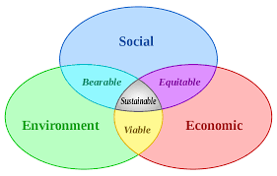

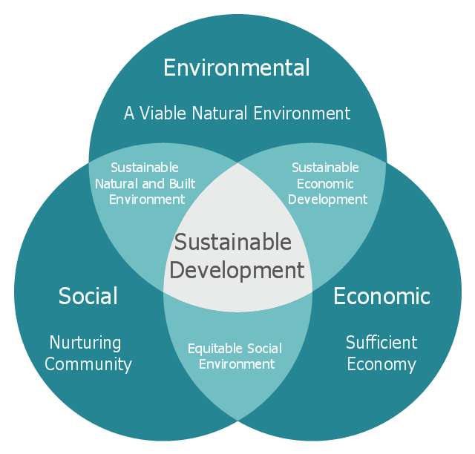

**Ecological approaches to restore Environment**

Although ecosystem (or ecological) restoration is defined as an intentional activity that initiates or accelerates the recovery of a degraded, damaged, or destroyed ecosystem with respect to its health, integrity, services, and sustainability (Society for Ecological Restoration International 2004). Sometime ecosystems may have been changed so dramatically that a return to the original landscape is no longer possible and rehabilitation or **on-site mitigation**—a partial return to a previous state―could be the only option. Reclamation is the process of reconverting disturbed land to its former or other productive uses. It is commonly used in the context of mined lands. The main objectives of reclamation include the stabilization of the terrain, assurance of public safety, aesthetic improvement, and usually a return of the land to what, within the regional context, is considered to be a useful purpose. Reclamation projects that are more ecologically based can qualify as rehabilitation or even restoration.  **Off-site mitigation** is an action intended to compensate for environmental damage. Regardless of approach, monitoring is needed to ensure the desired goals are actually achieve

At individual level practices like Reduce , Reuse, recycle, repair, renew ,replenish ,refill, replace are recommended to conserve the resources but at community /national/ regional level following strategies are recommended to restore the environment .

**Reclamation**: Chemical, biological or physical cleanup and reconstruction of severely contaminated or degraded sites to return them to something like their original topography or vegetation

**Restoration:** To bring something back to a former condition .ecological restoration involve active manipulation of nature to recreate conditions that existed before human disturbances

**Rehabilitation**: To rebuild elements of structure or function in an ecological system without necessarily achieving complete restoration to its original condition

**Replacement/Re-creation:** construction of entirely new biological community to replace one that has been destroyed on that or another site

**Remediation**: cleanup chemical contaminants from the polluted area

**Artificial Ecosystem**: Development of an artificial ecosystem offsite to support captive breeding

**Case example 4-3. BLM Blanca Wetland Restoration, Critical Habitat for Threatened, Endangered, and Sensitive Species, and Reliable Annual Contracts for Local Small Businesses in South-Central Colorado**

For thousands of years, much of the San Luis Valley basin of south-central Colorado was made up of a series of lakes, marshes, and shallow playa basins that were integral to the lives of indigenous peoples. By the mid1900s, the basins had dried up from the diversion of water sources for irrigation and became known as the “Dry Lakes.” In 1965, BLM began a series of wildlife habitat projects to restore some of the historic wetland characteristics and processes, and 9,600 acres of the former “Dry Lakes” area became known as Blanca Wetlands. BLM designated the Blanca Wetlands Area (BWA) as an “Area of Critical Environmental Concern” (ACEC) in 1991, due to its high importance for wildlife and recreational values. Today the BWA and the South San Luis Lakes system are managed by BLM to restore wetland habitat and provide wetland connectivity in the valley. BLM conducts wetland restoration activities across a 14,000-acre landscape, providing habitat to over 160 species of birds and 13 threatened, endangered and sensitive species, including bird, amphibian, fish, and plant species. Wetland restoration in the BWA includes drawing water from an irrigation canal and a series of artesian wells and developing an infrastructure system of ditches and dikes to promote water movement through the area. BLM also has an active science program, collecting and analyzing a variety of data to continually improve wetlands management. These activities have resulted in the restoration of over 200 playa lakes, ponds, and marshlands. This area that was once dry due to human-induced dewatering has now become a nationally significant migration and nesting area for many wildlife species, including Colorado’s largest breeding population of Western snowy plover. In FY 2011, BLM started investigating the possibility of enlarging the boundary of the ACEC to promote focused efforts toward wetland connectivity and restoration on a landscape scale.

**Economic Impacts of Restoration**. Restoration and monitoring activities in the BWA have been ongoing since the 1960s. Annual expenditures have been about $75,000 ($2011). Annual activities include site maintenance and infrastructure development, weed management, well certification, monitoring (to collect bird, amphibian, fish, macroinvertebrate, groundwater and water quality, soils, and vegetation data). These annual expenditures provide local firms with a reliable stream of work and support an average of over $29,000 in local labor income (salaries, wages, and benefits) each year. Over the next 10 years, BLM anticipates increased expenditures on deferred maintenance for wells and structures. Economic impacts in these years could support as much as $150,000 in labor income per year for local well drillers, welders, and heavy equipment operators.