Reduction Reactions
The reverse of each oxidation reaction in the previous sections is a reduction reaction.

General Features (17.6A)
The characteristics of reduction reactions are opposite to those of oxidation reactions. As a result, organic molecules lose oxygen and/or gain hydrogen in reduction reactions. While oxidation and reduction are equally important processes, we often describe reduction reactions using terms associated with oxidation. For example, when we reduce a molecule , we say it is in a "lower oxidation state" rather than in a "higher reduction state". Similarly, we measure the extent of reduction of a C atom by its "oxidation number". Finally, we describe the relative levels of reduction of various compounds using their "relative oxidation levels" as in Table 17.01.

Types of Reduction Reactions (17.6B)
We show important types of reduction reactions below We use the general symbol [H] to designate reduction because usually we add one or more H's to the molecule during its reduction. These H's typically come from molecular hydrogen (H2) or from metal hydride reagents that we describe below.
Figure 17.066
[H]
RC≡CR or R2C=CR2  Alkynes or Alkenes | →  [H] | RCH=CHR or R2CH-CHR2  Alkenes or Alkanes
R2C=O  Ketones or Aldehydes | →  [H] | R2CHOH or R2CH2  Alcohols or Alkyl Groups
R-C(=O)-Z  Carboxylic Acid Derivatives | →  [H] | R-C(=O)-H or R-CH2OH  Aldehydes or Alcohols
R-C≡N or R-NO2  Nitriles or Nitro compounds | → | R-CH2-NH2 or R-NH2  Amines

Reduction Using H2. In many of these reactions, it appears that one or more molecules of H2 adds across a multiple bond.
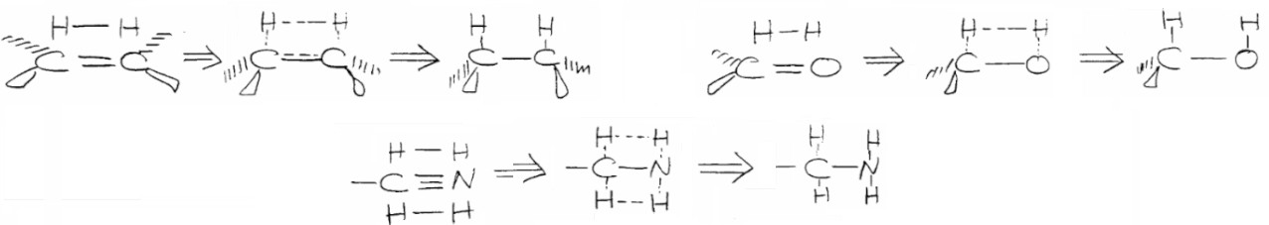
In fact, molecular H2 in the presence of various metal catalysts can reduce most multiple bonds. We describe this catalytic hydrogenation at the end of Chapter 10 for reduction of C=C and C≡C bonds given below. Figure 17.068
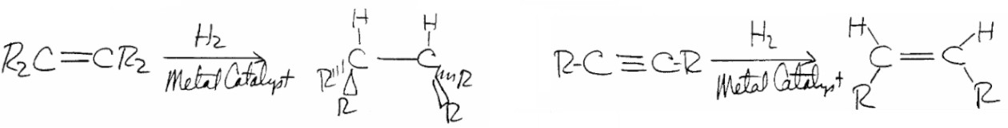
Since catalytic hydrogenation also reduces C=O, C=N, and C≡N bonds, this process often simultaneously reduces most or all of the multiple bonds in a molecule. Because of this lack of selectivity, we generally use catalytic hydrogenation to reduce C=C and C≡C bonds in molecules where other types of multiple bonds are not present or are protected.

Chemo-Selective Reduction reaction.
It is often necessary to reduce one group in a molecule without affecting another reducible group. It is usually possible to find a reducing agent that will do this. The most common broad-spectrum reducing agents are the metal hydrides and hydrogen (with a catalyst). Many different metal-hydride systems and hydrogenation catalysts have been investigated in order to find conditions under which a given group will be reduced chemoselectively. Tables 19.2–19.4 list the reactivity of various functional groups toward catalytic hydrogenation, LiAlH4, and BH3, respectively.
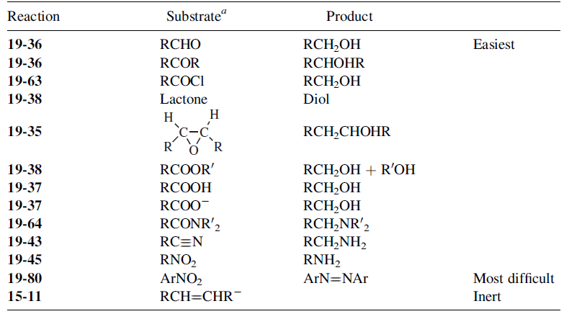

Table shows which groups can be reduced by catalytic hydrogenation and various metal hydrides. Of course, the tables cannot be exact, because the nature of R and the reaction conditions obviously affect reactivity. Nevertheless, the tables do give a fairly good indication of which reagents reduce which groups. Lithium aluminium hydride is a very powerful and unselective reagent. Consequently, other metal hydrides are generally used when chemoselectivity is required. As we know a number of less reactive (and more selective) reagents have been prepared by replacing some of the hydrogens of LiAlH4 with alkoxy groups (by treatment of LiAlH4 with ROH). Most of the metal hydrides are nucleophilic reagents and attack the carbon atom of a carbon-hetero single or multiple bond. Another useful reagent is LiAlHSeH. However, BH3 and AlH3 are electrophiles (Lewis acids) and attack the heteroatom.

Metal Hydride Reagents.
Organic chemists have developed a variety of metal hydride reagents that specifically reduce various types of multiple bonds. We show some particularly important examples that we describe in this chapter in Figure 17.069.
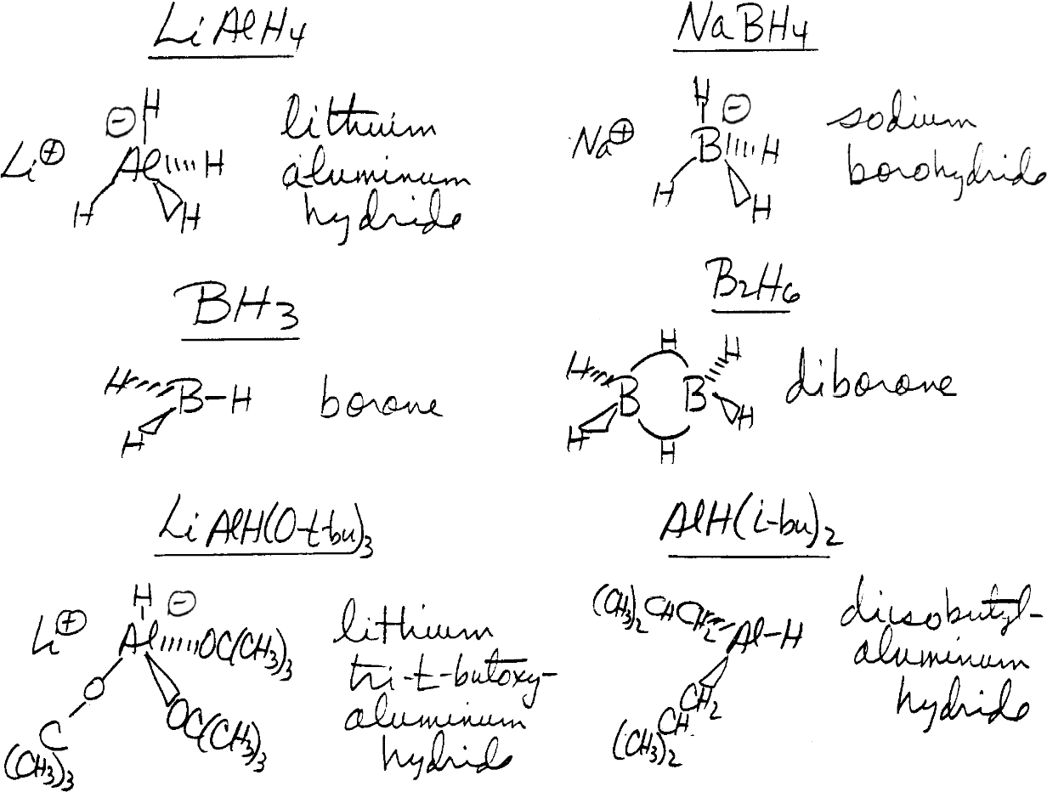
Figure 17.069

All of these reagents contain a boron (B) or aluminum (Al) atom bonded to one or more H atoms. They reduce multiple bonds by transferring an H with its bonding electron pair (a hydride ion) from B or Al to the positively polarized C atoms in C=O, C=N, and C≡N
bonds. We show a general representation of this type of reaction for an "Al-H" reagent and a C=O bond in Figure 17.070 .
Figure 17.070
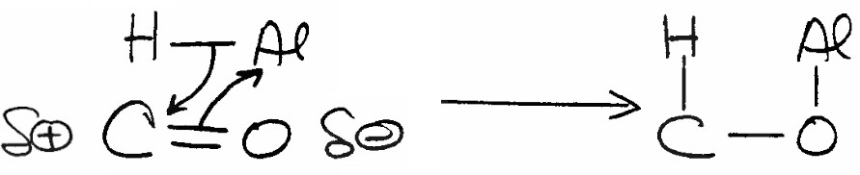
Presentation of Reduction Reactions. We describe the use of these reducing agents to carry out particular types of reduction reactions in the following sections titled Reduction of Ketones and Aldehydes, Reduction of R-C (=O)-Z and Related Compounds, and Reduction of C=C and C≡C Bonds.

Reduction of Ketones and Aldehydes
Reduction of ketones or aldehydes transforms their C=O groups to alcohol groups (HC-OH), or to CH2 groups (Figure 17.066). We list specific reactions in this section in Figure 17.071 .
Figure 17.071
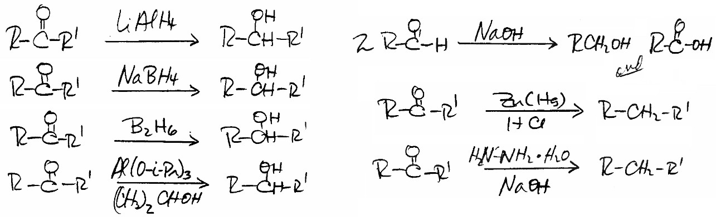

Alcohols from Metal Hydride Reductions (17.7A)
We show typical reaction conditions for LiAlH4, NaBH4, or B2H6 reductions of aldehydes or ketones to give alcohols in Figure 17.072. Because of the relatively low reactivity of NaBH4, we can use a protic solvent such as ethanol when NaBH4 is the reducing agent. In contrast, for LiAlH4 reductions we must us aprotic solvents such as ethers.
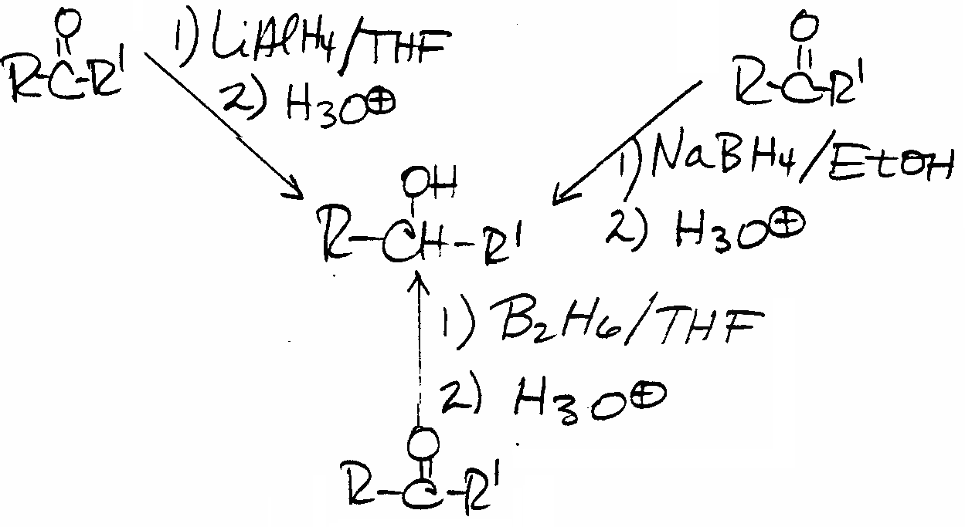

LiAlH4 reacts violently with alcohols or other protic solvents giving molecular H2 (Figure 17.073) that subsequently undergoes combustion with atmospheric oxygen
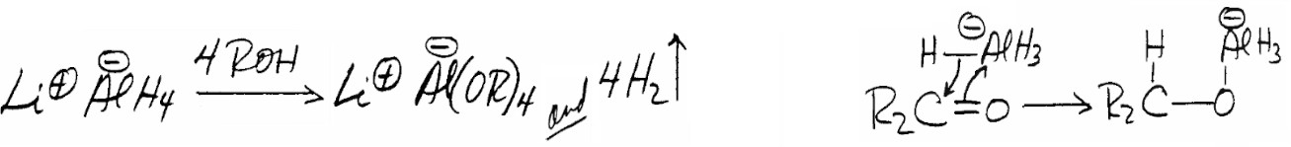
LiAlH4 Mechanism.
The mechanism for LiAlH4 reduction of a C=O group is complex with many reaction intermediates. In the first step, AlH4- transfers an H atom with its electron pair (a "hydride") to the C=O carbon (Figure 17.074)[see above]. In this step, the C=O double bond becomes an H-C-O single bond and the carbon atom is reduced. The resultant intermediate R2CH-O-AlH3- is probably complexed with Li+ and solvent molecules (usually diethyl ether or THF)
Figure 17.075

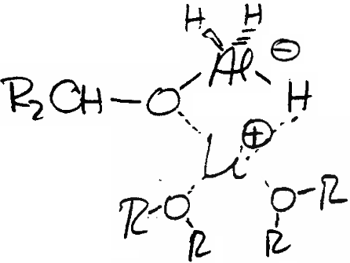

This intermediate can add hydride to unreacted R2C=O because it has Al-H bonds. However, it can also participate in a series of reactions that ultimately leads to the formation of
(R2CH- O)4Al- and AlH4- (Figure 17.076).
Figure 17.076
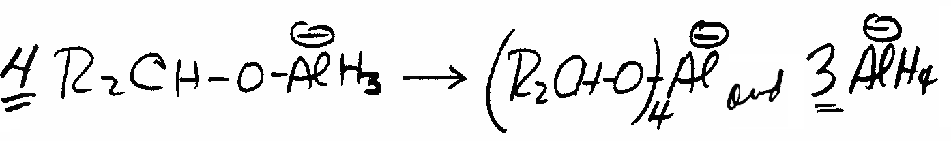
As a result, hydride transfer can occur from a variety of species. The alcohol product ultimately forms by hydrolysis of (R2CH-O)4Al- (Figure 17.077).
Figure 17.077
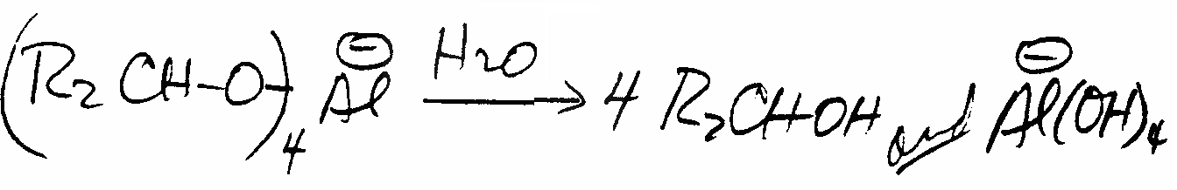
NaBH4 Mechanism. In the NaBH4 mechanism, ethanol (shown as R-OH) may transfer a proton to the O of the ketone or aldehyde simultaneously with hydride transfer from BH4- to the C (Figure 17.078).

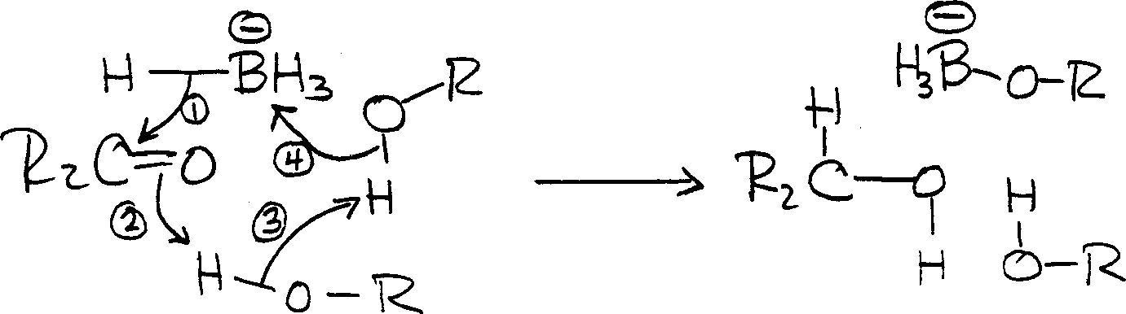
Figure17.07

After reduction of the carbonyl compound, aqueous acid neutralizes the basic reaction mixture (Figure 17.072). Intermediates such as CH3CH2O-BH3- may also serve as hydride ion donors to unreacted carbonyl compound.
Alcohols from Diborane Reduction.
Organic chemists use diborane (B2H6) less frequently than either LiAlH4 or NaBH4 to reduce ketones or aldehydes, but it is a useful reagent because of its selectivity (Figure 17.079).

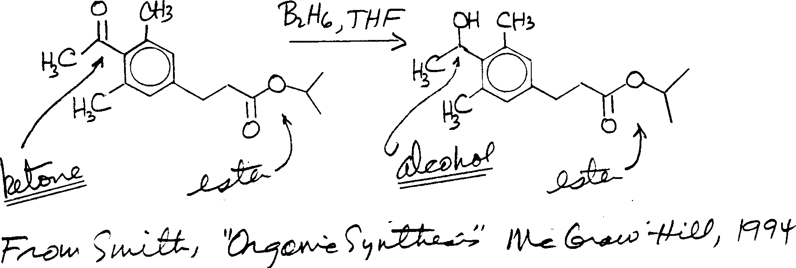
Figure 17.079
The hydride transfer reagent is probably BH3 that forms from B2H6 in the reaction mixture as we described in Chapter 10 and show again in Figure 17.080.
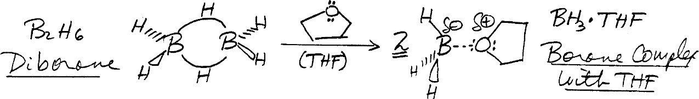
Figure 17.080

We give a mechanism for diborane reduction of a C=O group in Figure 17.081.
Figure 17.081
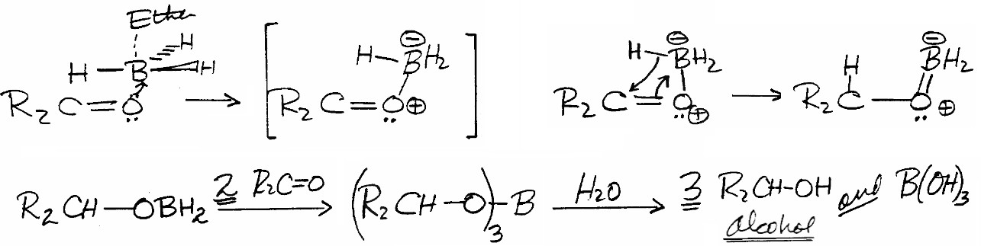
Neutral versus Complex Metal Hydrides.
Organic chemists classify lithium aluminum hydride (LiAlH4) and sodium borohydride (NaBH4) as complex metal hydrides because they are ionic compounds with negatively charged AlH4- and BH4- ions. In contrast, neutral metal hydrides such as BH3 (that exists in its dimeric form B2H6), have no charge. As a result, there is a profound difference in their reactivity and selectivity. Both AlH4- and BH4- are electron rich species that react by initially donating a hydride to the carbon atom of the multiple bond (Figures 17.074 and 17.078). In contrast, BH3 is an electron deficient Lewis Acid. In the first step of its reactions with C=O, C=N, and CN bonds, it bonds to an unshared electron pair on the heteroatom O or N. Subsequently, there is an intramolecular hydride transfer to C as we showed in Figure 17.081. Because BH3 is electron deficient (electrophilic), it also reacts with C=C and CC bonds. C=C and CC bonds prefer to donate electron density to electrophilic species rather than accept it from electron rich nucleophilic species such as BH4- and AlH4- (Figure 17.082).
Figure 17.082
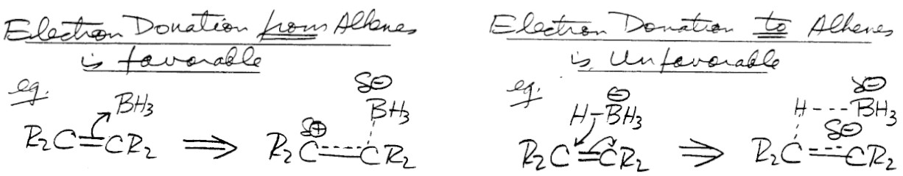

Alcohols from Organic Reducing Agents (17.7B)
We can form alcohols by reduction of ketones or aldehydes using two organic reactions that we have previously discussed as oxidation reactions. These are the Cannizzaro reaction and the Meerwein-Ponndorf-Verley reduction that is the reverse of the Oppenauer oxidation
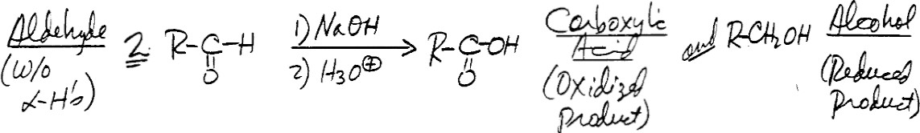
Cannizzaro Reaction. We show the Cannizzaro reaction again in Figure 17.083. Figure 17.083

Two molecules of an aldehyde (without α-H's) simultaneously oxidize and reduce giving an alcohol and a carboxylic acid. We gave the full mechanism earlier in Figure 17.023 and show the first steps again in Figure 17.083a.
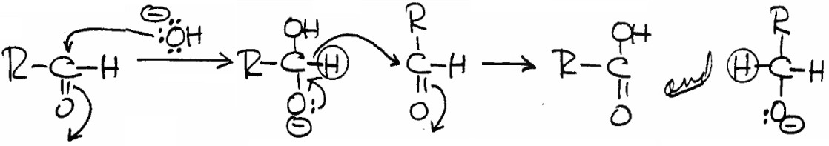
Figure 17.083a

This hydride transfer is analogous to those in metal hydride reductions, but the hydride transfer agent is a negatively charged organic compound.

Meerwein-Ponndorf-Verley Reduction. The M-P-V reduction is the reverse of the Oppenauer oxidation presented earlier. Treatment with Al(O-CH(CH3)2)3 (aluminum tri isopropoxide) in isopropyl alcohol (2-propanol) reduces ketones or aldehydes to alcohols (Figure 17.084).
Figure 17.084
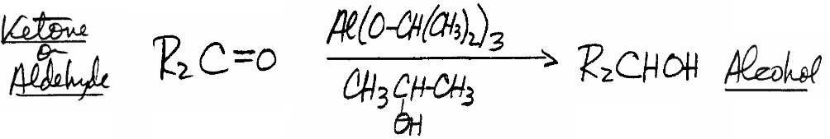
As in the Cannizzaro reaction, there is a hydride transfer to the carbonyl compound that forms the alkoxide ion of the desired product alcohol (Figure 17.085).
Figure 17.085
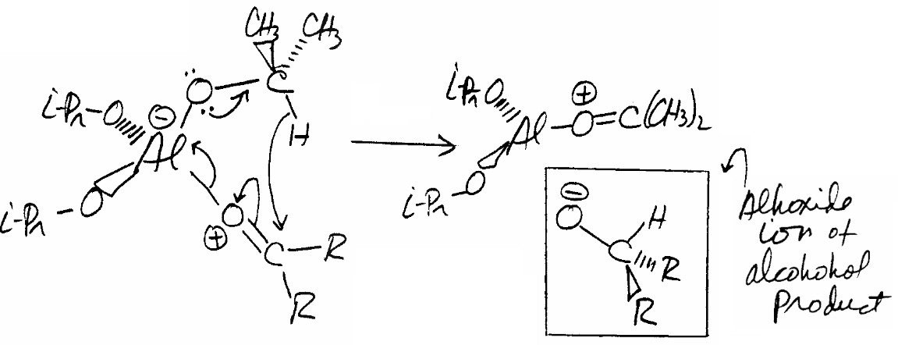
You can see that the hydride comes from the isopropoxide group (1-methylethoxide group) in aluminum triisopropoxide.

Alkyl Groups from C=O Reduction (17.7C)
We can convert the C=O group of ketones and aldehydes into a CH2 group (Figure 17.086), by the Clemmensen reduction or the Wolff-Kishner reaction.
Figure 17.086

Clemmensen Reduction
R2C=O → → → → R2CH2
Wolff-Kishner Reaction

Clemmensen Reduction. We carry out this reaction by treating an aldehyde or ketone with zinc amalgam (Zn treated with mercury metal (Hg)) in aqueous HCl (Figure 17.087).
Figure 17.087
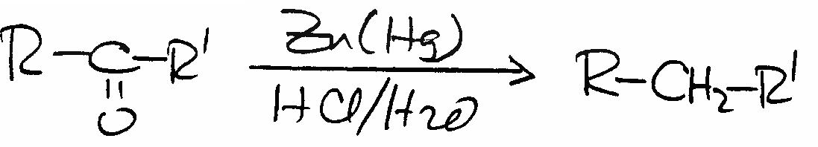
Because this reaction uses aqueous HCl, it is not useful for compounds that are sensitive to acid.While its mechanism is uncertain, the corresponding alcohol R2CHOH is not formed as an intermediate

Wolff-Kishner Reaction. In this reaction, treatment of an aldehyde or ketone with H2N- NH2.H2O (hydrazine hydrate) and NaOH in a high boiling solvent such as refluxing diethylene glycol (HOCH2CH2OCH2CH2OH) (Figure 17.088) transforms their C=O groups into CH2 groups.
Figure 17.088 Figure 17.089
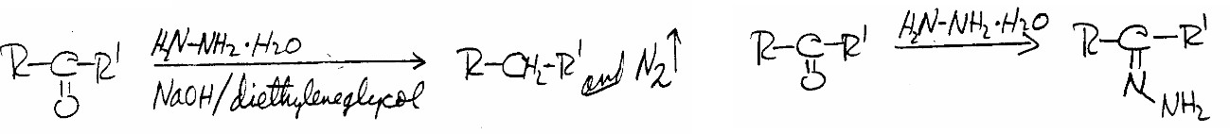
Wolff-Kishner reaction mechanism involves nucleophilic addition of hydrazine to the C=O group to form the intermediate hydrazone (Figure 17.089)[see above]. This intermediate reacts further with HO- in the reaction mixture to form N2 and the final organic product (Figure 17.090).
Figure 17.090
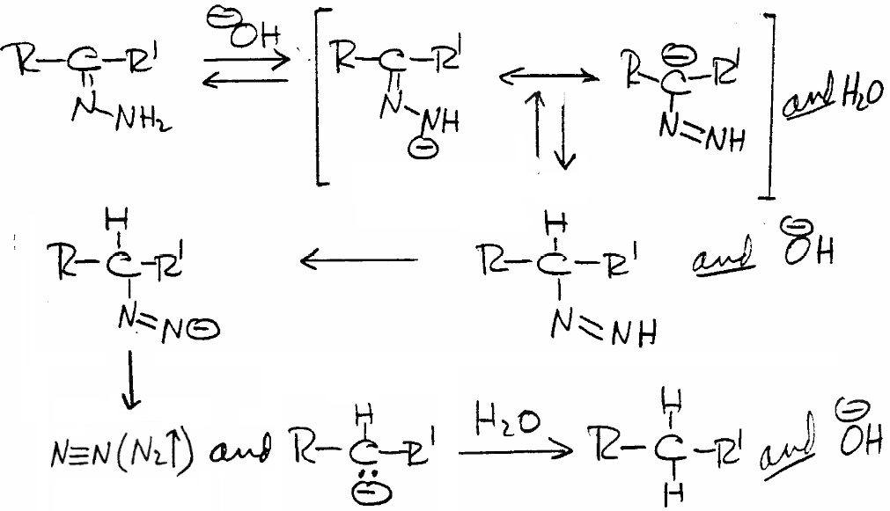
Because the reaction medium is basic, we can use the Wolff-Kishner reaction with compounds sensitive to the acidic conditions of the Clemmensen reduction.

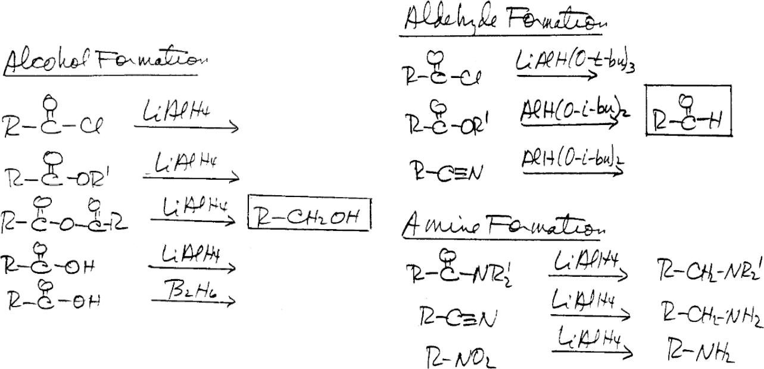
Reduction of R-C(=O)-Z and Related Compounds When we reduce esters, amides, or other compounds of the structure R-C(=O)-Z, possible products are alcohols,

amines, or aldehydes. The type of product depends on the structure of R-C(=O)-Z and that of the metal hydride reducing agent (Figure 17.091). We describe reductions of R-C(=O)-Z in this section along with those of nitriles (R-CN) and nitro compounds (R-NO2).
Alcohol Formation (17.8A)
LiAlH4 reduction of R-C(=O)-Z compounds except amides (Z = NR'2) gives alcohols (R- CH2-OH) (Figure 17.091). Aldehydes are intermediates in these reactions (Figure 17.092).
Figure 17.092
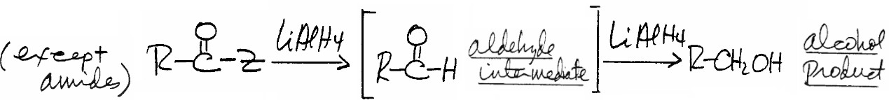

General LiAlH4 Mechanism. We show a general mechanism for LiAlH4 reduction of R- C(=O)-Z other than amides in Figure 17.093.
Figure 17.093
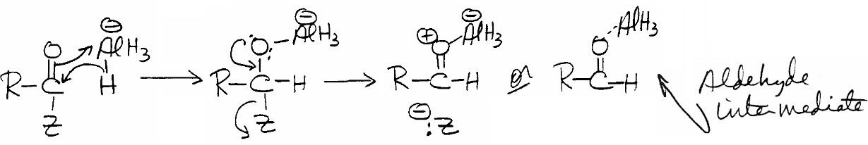
After the initial hydride addition to the C(=O)-Z group, Z- leaves to give an aldehyde intermediate that AlH4-, or another other reactive intermediate with Al-H bonds, reduces further to an alcohol (Figure 17.074).
Carboxylic Acid Reduction.

When we reduce carboxylic acids with LiAlH4, an initial acid-base reaction forms a carboxylate intermediate complexed to AlH3 (Figure 17.094) .An intramolecular hydride transfer reaction in this complex then leads to reduction of the carboxylate functional group to an aldehyde that is further reduced to an alcohol.

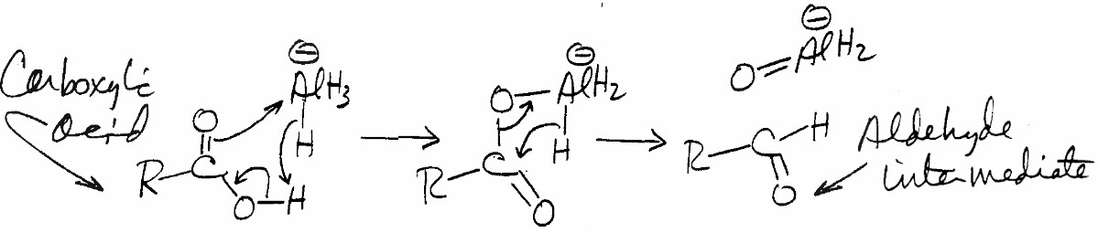

Diborane Reduction of Carboxylic Acids. We can also reduce carboxylic acids to alcohols using B2H6 (Figure 17.095).
Figure 17.095
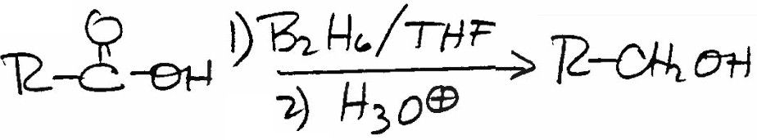
While LiAlH4 reduces acids, it also reacts with any other C=O groups that are present in the molecule. In contrast, diborane does not reduce other R-C(=O)-Z groups that may be
Present Figure 17.094

Amine Formation (17.8B)
Amines are the products when we reduce amides (R-C(=O)-NR'2), nitriles (R-C≡N), or nitro compounds (R-NO2) with LiAlH4 (Figure 17.091).

Reduction of Amides. LiAlH4 reduction of amides (R-C(=O)-NR'2) gives 1° amines (R- CH2-NH2), 2° amines (R-CH2-NHR') or 3° amines (R-CH2-NR'2) depending on the the number of H's on N. The intermediate formed in the first reaction of LiAlH4 with an amide (Figure 17.096) is equivalent to that formed in the first reaction when LiAlH4 reacts with other R-C(=O)-Z compounds (Figure 17.093).
Figure 17.096
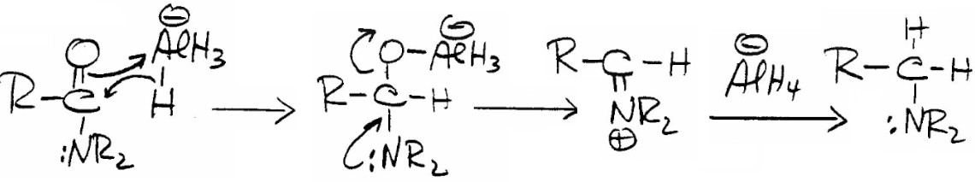
However in the case of amides, the Z group is NR'2 and the -NR'2 anion is such a poor leaving group that an "O-Al" anion leaves instead (the second reaction in Figure 17.096) giving an intermediate iminium ion. Subsequent reduction of that iminium ion (or its imine form) gives the amine as we show in the third reaction in that figure.

Reduction of R-C≡ N and R-NO2. Reduction of nitriles (R-C≡N) has a stepwise mechanism in which C≡N becomes C=N and finally a C-N bond (Figure 17.097)
Figure 17.097

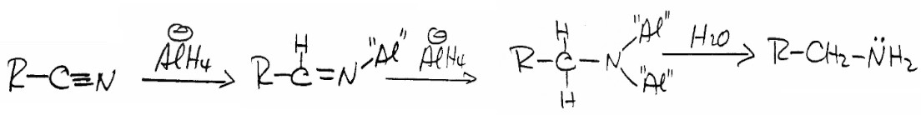
Although we give no mechanism for reduction of nitro compounds (R-NO2), this reaction is particularly useful for synthesis of anilines from nitrobenzenes (Figure 17.098).
Figure 17.098
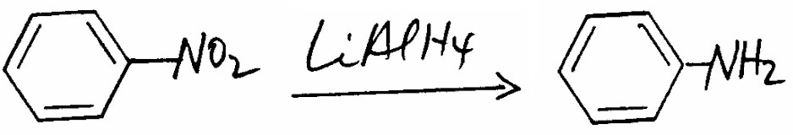
Aldehyde Formation (17.8C)
We obtain aldehydes as final products when we use the modified aluminum hydride reagents in Figure 17.091 to reduce acid halides ((R-C(=O)-Cl), esters ((R-C(=O)-OR'), or nitriles (R- C≡N).
Acid Halides and LiAlH(O-C(CH3))3. One of these modified reagents is lithium tri-t- butoxyaluminum hydride (LiAlH(O-C(CH3))3) that we form by reaction of LiAlH4 with t- butyl alcohol (Figure 17.099).
Figure 17.099
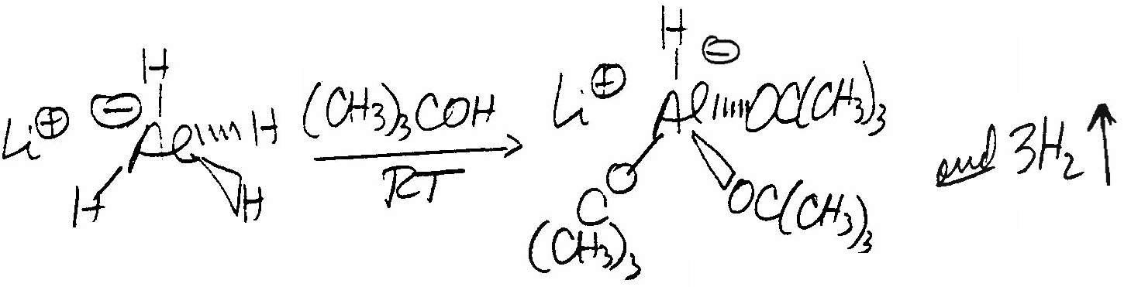
The reaction stops after three OC(CH3)3 groups replace three of the four H's on Al. This is a result of a combination of steric crowding at the Al atom, and reduced reactivity of the final Al-H hydride because of electronic effects of the new t-butoxy group substituents. This metal hydride probably reacts with acid halides according to the scheme in Figure 17.100.
Figure 17.100
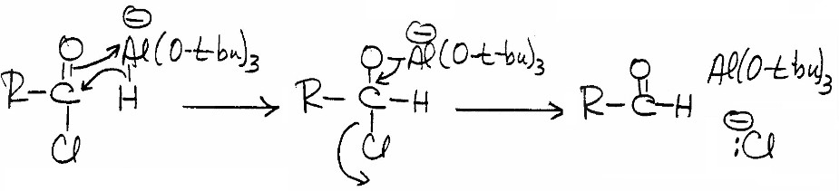
The intermediate must decompose to give aldehyde after all of the AlH(O-t-bu)3- reagent has reacted since unreacted reactant will reduce aldehydes to alcohols
Esters and Diisobutylaluminum Hydride (DIBAL). DIBAL is a metal hydride with the general structure R2AlH where R = isobutyl (Figure 17.101) [next page].
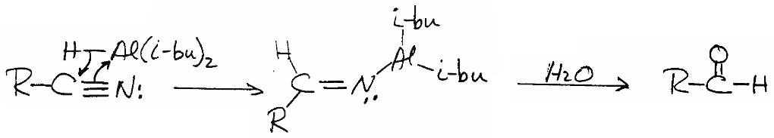
Nitriles and DIBAL. DIBAL reduces nitriles (Figure 17.103). Figure 17.103

The intermediate in the first reaction does not react further with DIBAL because of steric hindrance. During treatment of the reaction mixture with aqueous acid, it hydrolyzes to give an aldehyde. This reaction is equivalent to the formation of an aldehyde from an imine by hydrolysis
Rosenmund Reduction.
We can also reduce acid halides to aldehydes using molecular H2 instead of metal hydrides. We show this Rosenmund reduction in Figure 17.104. The second set of reaction conditions involving Pd(C) is often the best choice.
Figure 17.104
H2, Pd(BaSO4)
R-C(=O)-Cl → R-C(=O)-H
or

H2, Pd(C)
R-C(=O)-Cl → R-C(=O)-H
Et(i-Pr)2N, acetone

Reduction of C=C and C≡C Bonds
We discussed reduction of alkenes and alkynes (Figure 17.105) in Chapter 10.
Figure 17.105
We review that material again here along with a brief discussion of arene reduction.

Reduction of Alkenes and Alkynes (17.9A)
Reductions of alkenes and alkynes generally involve catalytic hydrogenation. In the case of alkyne reduction to alkenes, catalytic hydrogenation takes place with cis addition of H2. We can also reduce alkynes using Na in liquid NH3 with different stereochemical results then catalytic hydrogenation (Figure 17.106.)
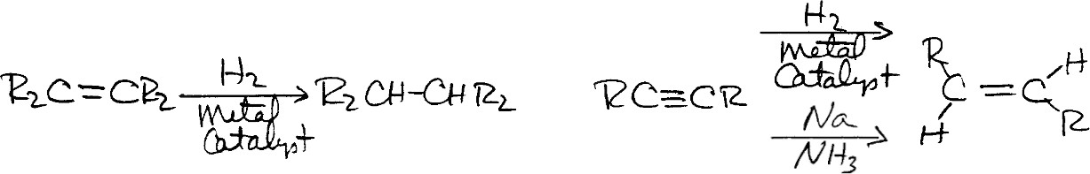
Figure 17.106
The reaction of alkenes with diborane to give alkylboranes (Chapter 10) (Figure 17.107) is also a reduction reaction.
Figure 17.107 Figure 17.108

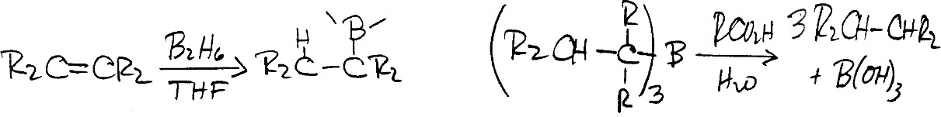
We convert the alkylboranes to alkanes by reacting them with aqueous carboxylic acids (Figure 17.108) (see above).

Reduction of Arenes (17.9B)
Reduction of arenes (benzenes) via catalytic hydrogenation gives cyclohexanes (Figure 17.109).
Figure 17.109
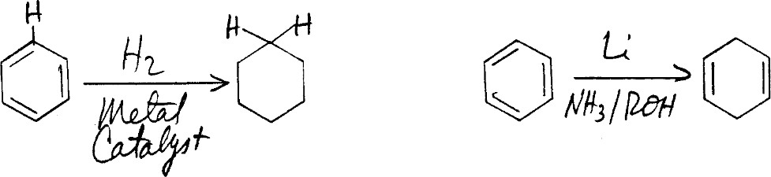

In contrast, reaction of arenes with Li, Na, or K metal dissolved in liquid NH3 in the presence of an alcohol, gives 1,4-cyclohexadienes. This Birch reduction is applicable to a variety of aromatic rings as we show in the examples in Figure 17.110.
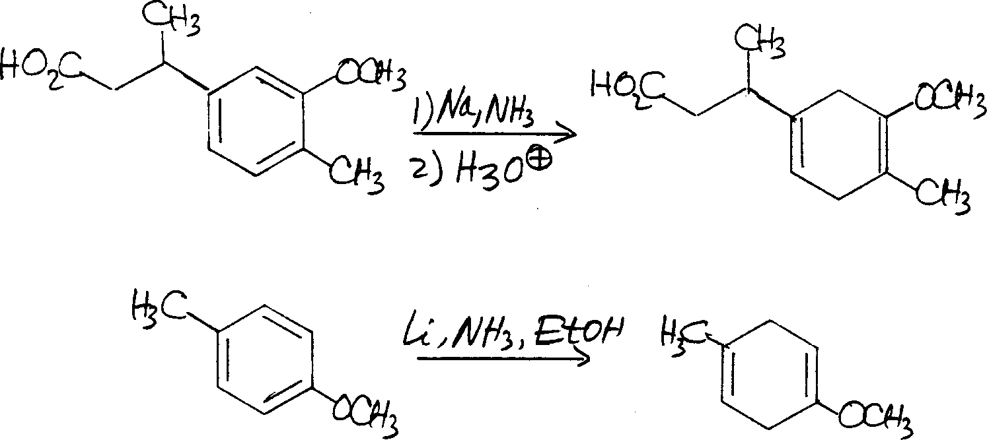
Figure 17.1

