Oxidation of Aldehydes and ketones
Many of the stronger oxidizing agents such as KMnO₄ will transform aldehydes into carboxylic acids. Tol- lens' reagent [Ag(NH₃)₂]⁺ is one such oxidant. A shiny mirror of metallic silver is deposited through oxidation of aldehydes by Tollens' reagent, so it is a frequently used test for aldehydes in qualitative analysis. Aldehydes are themselves oxidation products of alcohols.
A strong oxidizing agent like KMnO₄ will oxidize a primary alcohol past the aldehyde and up to the carboxylic acid oxidation state, while other, weaker oxidizing agents, like PCC, can be used to form aldehydes from alcohols, not proceeding to oxidize the aldehyde further. In general, normal ketones are not oxidized except under extreme conditions. At high temperature, ketones are cleavage oxidized by a strong oxidizing agent like KMnO₄. An exception is a benzylic carbonyl group, which KMnO₄ oxidizes easily.
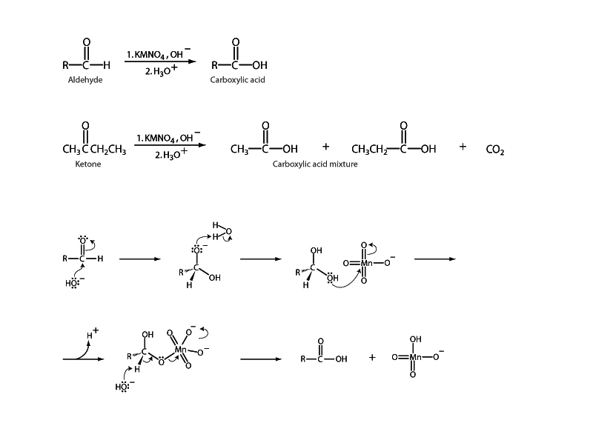

MECHANISM FOR THE ACID CATALYSED FORMATION OF HYDRATES
Step 1:
An acid/base reaction. Since there is only a weak nucleophile we need to activate the carbonyl by protonating on O.
Step 2:
The nucleophilic O in the water attacks the electrophilic C in the C=O, breaking the π bond and giving the electrons to the positive O
Step 3:
An acid/base reaction. Deprotonation of the oxonium ion neutralises the charge giving the hydrate.

- Aldehydes, RCHO, can be oxidised to carboxylic acids, RCO₂H.
- Ketones are not oxidised under these conditions as they lack the critical H for the elimination to occur (see mechanism below).
- The reactive species in the oxidation is the hydrate formed when the aldehyde reacts with the water.
- Typical reagents are aqueous Cr (VI) species

OXIDATION OF ALDEHYDES
Part 1:  Formation of the hydrate (mechanism) occurs first. | 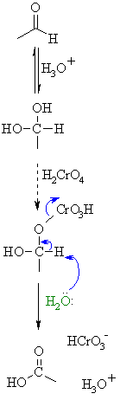
Part 2:
Now we essentially have an alcohol which reacts with the chromium species to form a chromate ester.
Part 3:
A base (here a water molecule) abstracts a proton from the chromate ester, the C=Oforms and a Cr species leaves. This is really an E2 elimination reaction. Note the importance of the original aldehyde H... if its' missing, no oxidation can occur.

The Baeyer-Villager Reaction
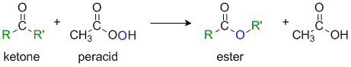
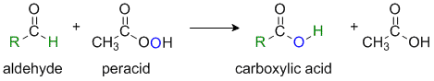
Reaction type: Oxidation-reduction via Nucleophilic addition
Summary
- Ketones, RCOR', are oxidised by peracids (or hydrogen peroxide) to give esters, RCO₂R'.
- Aldehydes, RCHO, are oxidised under the same conditions to give carboxylic acids, RCO₂H.
- For ketones, it can be viewed as the insertion of O into one of the C-C bonds adjacent to the carbonyl.
- For non-symmetrical systems, there is a selectivity issue to be aware of, and experimental evidence shows that it is usually the more highly substituted alkyl group that migrates and becomes attached to the inserted O atom. : i.e. (more likely) H > 3º R > 2º R, Ar > 1º R > -CH₃ (less likely)
- This is described as the migratory aptitude of the group and relates to the ability of the group to stablise +ve charge (nucleophilicity).
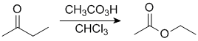 | In this example the primary ethyl group migrates in preference to the methyl group so we end up with an ethyl ester.
- Cyclic ketones give cyclic esters which are also known as lactones.
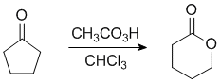
lactone
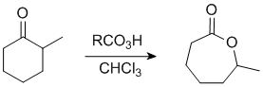
In this example the O ends up on the more substituted side.
THE BAEYER-VILLAGER REACTION
Step 1:  An acid/base reaction. Protonation of the carbonyl activates it while creating a more reactive nucleophile, the percarboxylate. | 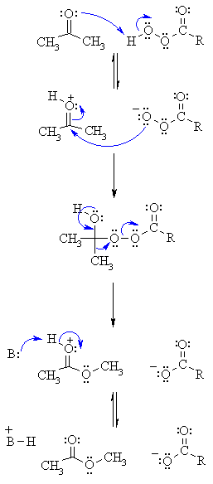
Step 2:
Now the nucleophilic O attacks the carbonyl C with the electrons from the C=O π bond going to the positive O.
Step 3:
Electrons from the O come back (this reforms the π bond of the C=O) and we migrate the C-C electrons to form a new C-O bond displacing the carboxylate as a leaving group.
Step 4:
Finally an acid/base reaction reveals the C=Oand therefore the ester product.

