LIFE HISTORY PATTERN

- The life history of a species is the pattern of survival and reproduction events typical for a member of the species (essentially, its lifecycle).
- Life history patterns evolve by natural selection, and they represent an "optimization" of tradeoffs between growth, survival, and reproduction.
- One tradeoff is between number of offspring produced and the amount of energy (both physical resources and parental care) put into each offspring.
- Timing of first reproduction is another tradeoff. Early reproduction lowers the chance of dying without offspring, but later reproduction may allow organisms to have more or healthier offspring or to provide better care.
- Members of some species reproduce only once (semelparity), while members of other species can reproduce multiple times (iteroparity).

What is a "life history"?
What does your life history look like? In the world of ecology, that question doesn't refer to the many challenges and successes you've experienced, or to the friendships you've made along the way. (Not that those aren't good too!)
Instead, when we're talking about life history in ecology, we're thinking about basic demographic features of a population or species – the kind of things that would appear in a life table. That includes when organisms first reproduce, how many offspring they have in each round of reproduction, and how many times reproduction occurs. For humans, life history involves a late start to reproduction, few offspring, and the ability to reproduce multiple times.
We can define the life history of a species as its lifecycle, and in particular, the lifecycle features related to survival and reproduction^11start superscript, 1, end superscript. Life history is shaped by natural selection and reflects how members of a species distribute their limited resources among growth, survival, and the production of offspring.

Life history strategies and natural selection
All living things need energy and nutrients to grow, maintain their bodies, and reproduce. In nature, these resources are in limited supply, and there is often competition for access to them (e.g., to sunlight and minerals for plants or food sources for animals). Thus, each organism will have non-infinite resources to divide among activities like growth, body maintenance, and reproduction.
What does it mean for an organism to allocate its limited resources "well" in this context? From an evolutionary standpoint, it means that the resources are distributed among the potential activities (growth, maintenance, reproduction) in a way that maximizes fitness, or the number of offspring the organism leaves in the next generation. Organisms with inherited traits that cause them to distribute their resources in a more effective way will tend to leave more offspring than organisms lacking these traits, causing the traits to increase in the population over generations by natural selection^{2,3}2,3start superscript, 2, comma, 3, end superscript.
Over very long periods of time, this process results in species with life history strategies, or collections of life history traits (number of offspring, timing of reproduction, amount of parental care, etc.), that are well-adapted for their role and environment. The optimal life history strategy may be different for each species, depending on its traits, environment, and other constraints^{2}2squared.
In this article, we'll examine some tradeoffs in life history strategies and see examples of plants and animals that use strategies of different types.

Parental care and fecundity
One major tradeoff in life history strategies is between number of offspring and a parent's investment in the individual offspring. Basically, this is a "quantity versus quality" question: an organism can have many offspring that each represent a relatively small energy investment, or few offspring that each represent a relatively large energy investment.
To put this more formally, we can say that fecundity tends to be inversely related to the amount of energy invested per offspring. Fecundity is an organism's reproductive capacity (the number of offspring it's capable of producing). The higher the fecundity of an organism, the less energy it's likely to invest in each offspring, both in terms of direct resources – such as fuel reserves placed in an egg or seed – and in terms of parental care.
- Organisms that produce large numbers of offspring tend to make a relatively small energy investment in each, and don't usually provide much parental care. The offspring are "on their own," and the idea is that enough are produced that some will survive (even if the odds for any one are low).
- Organisms that make few offspring usually make a large energy investment in each offspring and often provide lots of parental care. These organisms are effectively "putting their eggs in one basket" (literally, in some cases!) and are heavily invested in the survival of each offspring.
As for so many cases in biology, these are general trends and not universal rules. The main point is just that when organisms have many offspring, they can't invest as much energy in any single offspring. When they have fewer, they can (and must) invest more energy to ensure those offspring's survival.

Example: Many offspring, low investment/parental care
A typical sea snail (whelk) produces hundreds of eggs at a pop, and these eggs hatch to yield baby snails that are pretty self-sufficient from the get-go. In fact, the baby snails in the first 10\%10%10, percent of eggs that hatch will enthusiastically eat their slower-hatching siblings for breakfast

Resource allocation
s the process of assigning and managing assets in a manner that supports an organization's strategic goals. Resource allocation includes managing tangible assets such as hardware to make the best use of softer assets such as human capital.
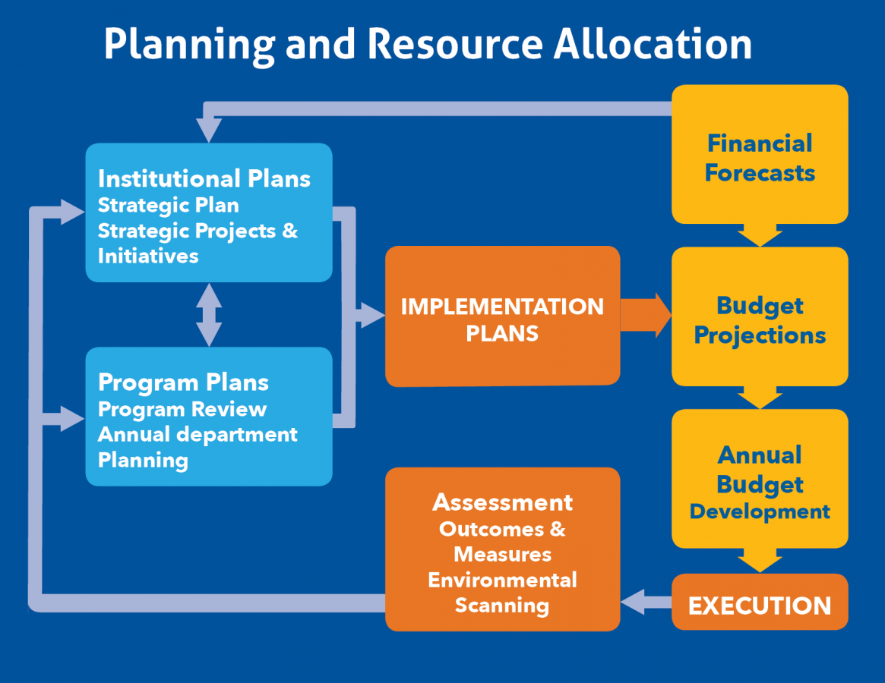

Resource allocation is just a fancy term for a plan that you develop for using the available resources at your disposal in a project. This is mostly a short-term plan set in place to achieve goals in the future.
Resources are varied. Everything from the people you’re working with and the equipment they’re using to complete their tasks to the materials and other supplies you need to even the site where you’re working on the project all fall under the umbrella of resources.
That’s a lot to allocate.
Don’t worry we’ve got your back. The following are some general tips to help you with your resource allocation when managing a project.

=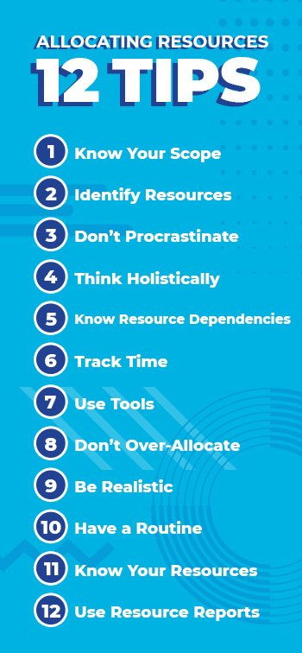

Density-dependent regulation can be affected by factors that affect birth and death rates such as competition and predation. Density-independent regulation can be affected by factors that affect birth and death rates such as abiotic factors and environmental factors, i.e. severe weather and conditions such as fire
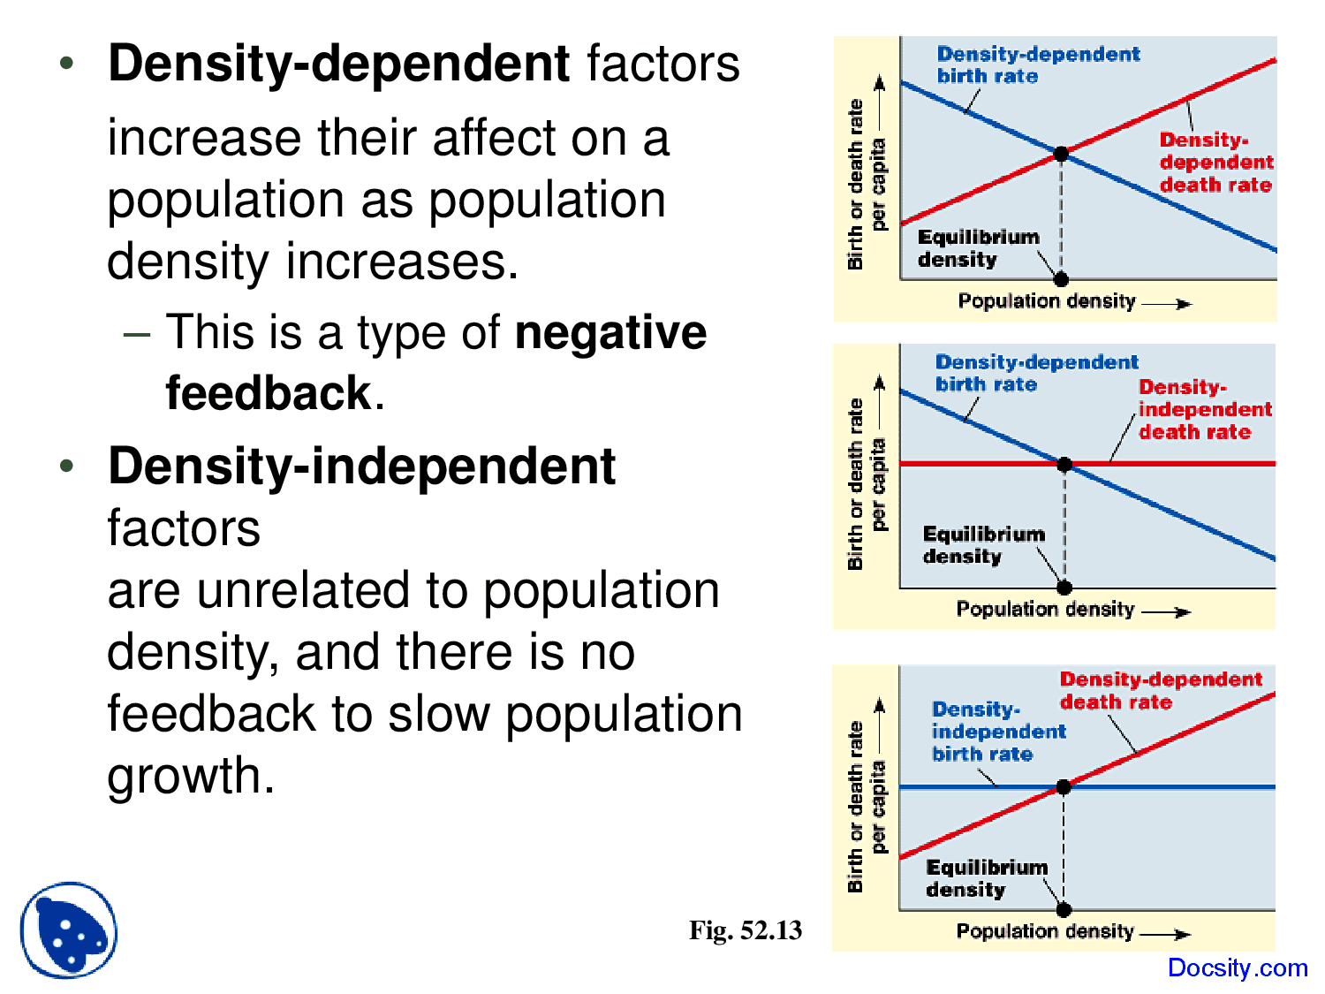

Reproductive effort is defined as that proportion of the total energy budget of an organism that is devoted to reproductive processes. Reproductive effort at a given age within a species will be selected to maximize reproductive value at that age.

Population geneticists usually define 'evolution' as any change in a population's genetic composition over time. The four factors that can bring about such a change are: natural selection, mutation, random genetic drift, and migration into or out of the population.

