PHOSPHORUS REMOVAL
Enhanced biological phosphorus removal (EBPR) is a sewage treatment configuration applied to activated sludge systems for the removal of phosphate. ... Therefore, as bacteria in a wastewater treatment plant consume nutrients in the wastewater, they grow and phosphorus is incorporated into the bacterial biomass

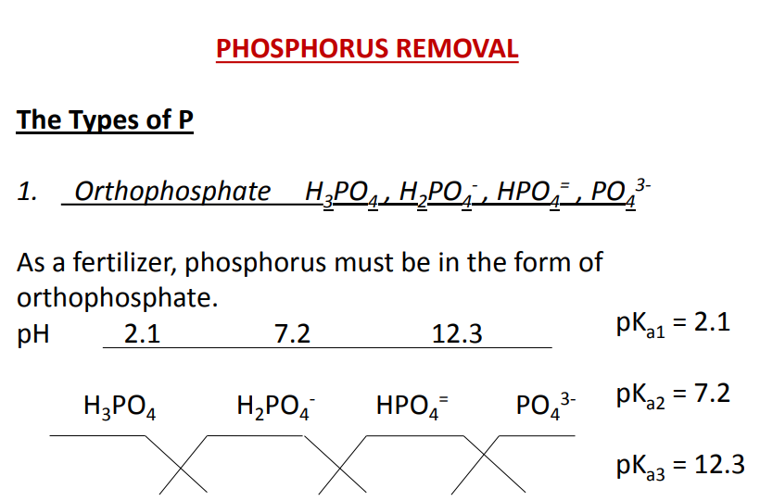
In the pH range of wastewaters (around 7), the dominant forms of orthophosphate are H2PO4 - and HPO4 = . As the pH increases, the equation moves toward the formation of PO4

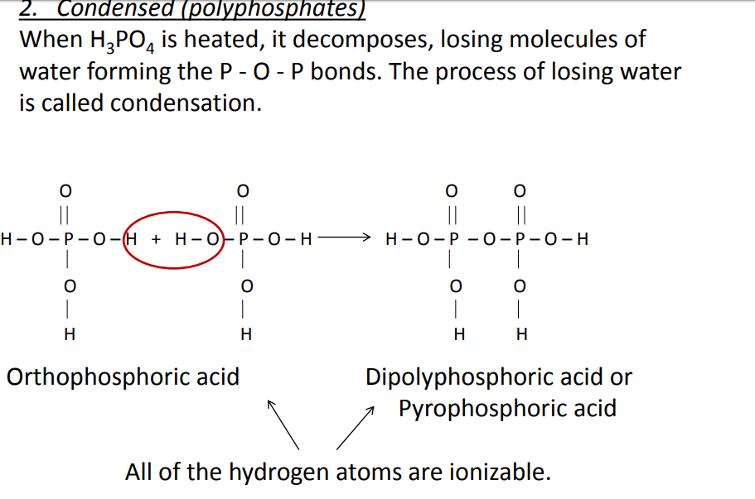

Properties of condensed phosphates
• Condensed phosphates are inorganic and contain more than one P per molecule. • They are used in corrosion control and in detergents as complexation agents. Ex. Pyrophosphate H4P2O7 and its ionization products. • They do not form precipitates. But they undergo hydrolysis in aqueous solutions and transform into the orthophosphates. • Microorganisms convert polyphosphates into orthophosphates.
Organic P :
When organic compounds containing P are attacked bymicroorganisms, they also undergo hydrolysis into theorthophosphate forms. Typical municipal waste : 10 – 15 mg/L as P 30 % from human waste + 70 % from detergents (mostly in the form of polyphosphates) P being a nutrient, causes algal blooms (eutrophication)

In most lakes P is the growth limiting nutrient for algae. P > 0.01 mg/L stimulates algal growth.
- 80 % removal of P or a residual of 1 mg/L as P is required in effluents discharged to streams which are tributaries to lakes.
- Effluent concentrations are commonly specified to be 1 mg/L or less to minimize environmental effects.
- Primary clarification removes 5 – 10 % of P.
- Primary + secondary treatment removes 10 – 20 % of
The most common method to remove phosphorus from a waste stream is chemical precipitation. The common precipitating cations used are Ca, Al and F
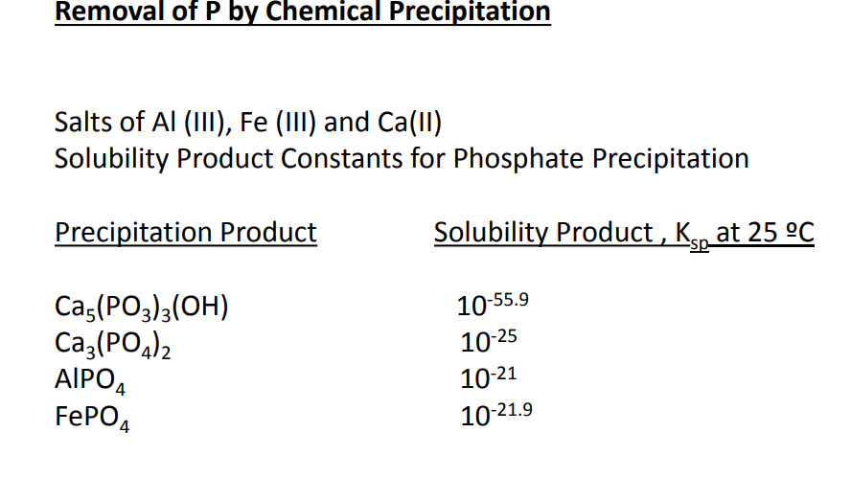

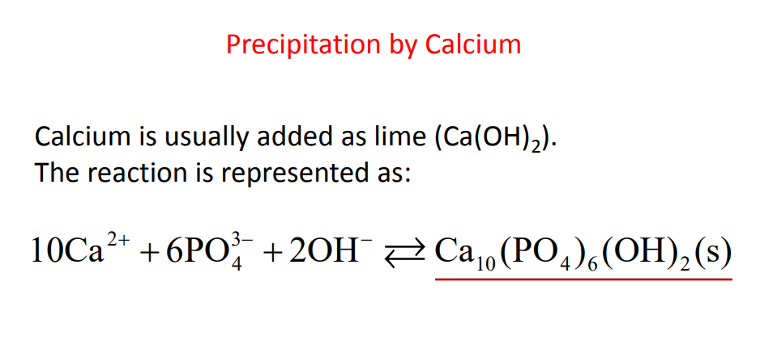 Calcium Lime dosage is primarily a function of system alkalinity. • The key parameter here is pH. • pH has to be elevated to somewhere between 10.5 and 11 to get effective P removal. • As a rule of thumb, lime dose to attain this pH is about 1.5 times the alkalinity represented in mg/L as CaCO3
Disadvantages of lime addition Lime addition is seldom practiced because • it produces large amount of sludge, and • the elevated pH has to be readjusted typically by recarbonation. 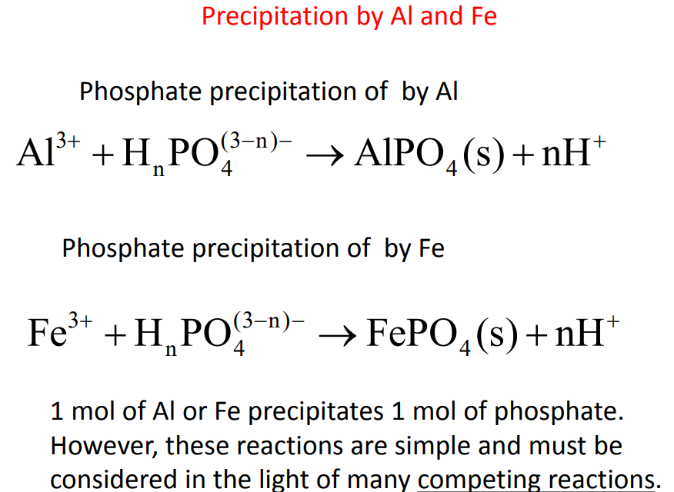

The chemistry of phosphate precipitate formation is complex because of complexes formed between phosphate and metals, and between metals and other ligands in the wastewater. ♣ Side reactions of the metals with alkalinity to form hydroxide precipitates are another factor to be considered. ♣ The amount of metal needed to remove phosphorus exceeds the stoichiometric amount at the low levels at which phosphorus is present in a wastewater.

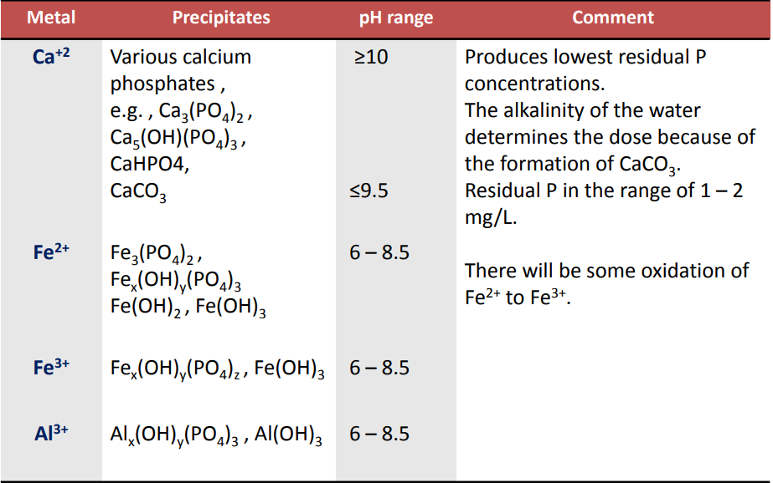
The common precipitates formed by the metals are given in the following table
In order to determine the chemical requirement, site specific experiments, which involve testing the amount of phosphorus removal at different dosages, are needed. •
- Chemical requirement depends upon ⎫ pH, ⎫ Alkalinity, ⎫ initial PT , and ⎫ desired % P removal
On-site tests under actual plant conditions are preferred. • A reasonably good correlation can be obtained by plotting t Common treatment methods include aeration, flocculation, sedimentation, filtration, and disinfection. In addition, the water supply needs to be checked at regular basis to ensure that satisfactory water quality is maintained.he log of the fraction of soluble phosphorus remaining as a function of the weight ratio of metal to soluble phosphorus. • The required ratio of metal ion to influent soluble phosphorus for a specified phosphorus removal can be obtained from such a plot. • This ratio is multiplied by the soluble influent phosphorus concentration in mg/L to determine the required chemical dose in mg/L

