Fermentation Biotechnology
It is defined as the use of biological systems, living organisms or derivatives to make or modify products or processes for specific use.
Apart from referring to a type of energy metabolism, fermentation in the industrial sense is regarded as any process for the production of various chemical or pharmaceutical compounds by means of the mass cultivation of micro-organisms. Thus, fermentation biotechnology concerns the use of micro-organisms such as bacteria or yeasts, or cellular components such as enzymes, to alter living or non-living materials for the production of knowledge, goods and services.
Fermentation as a biochemical Process
Fermentation is a metabolic process that converts sugar to acids, gases, or alcohol. Fermentation is also used more broadly to refer to the bulk growth of microorganisms on a growth medium, often with the goal of producing a specific chemical product. The science of fermentation is known as zymology.In the presence of O₂, NADH and pyruvate are used to generate ATP in respiration. This is called oxidative phosphorylation, and it generates much more ATP than glycolysis alone.
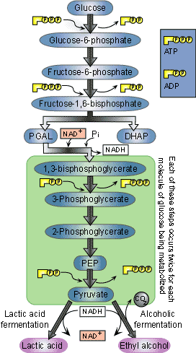

Microbial Process and raw material
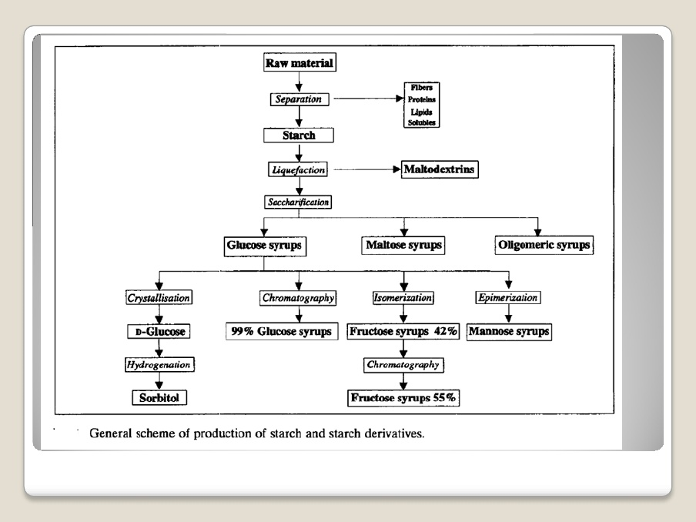

Microorganisms used in fermentation
Nature uses microorganisms to carry out fermentation processes, and for thousands of years mankind has used yeasts, moulds and bacteria to make food products such as bread, beer, wine, vinegar, yoghurt and cheese, as well as fermented fish, meat and vegetables. Micro-organism detriment undesirable flora in order to prevent spoilage and promote taste and texture. The first realisation that microorganisms were involved in food production processes was in 1837, when scientists discovered the role of yeast in an alcoholic Later Louis Pasteur was trying to explain what happened during the production of beer and vinegar in the 1860, he found that microorganisms were responsible fermentation. Functional properties of microorganisms in fermented foods include probiotics properties, antimicrobial properties, antioxidant, peptide production, fibrinolytic activity, poly-glutamic acid, degradation of antinutritive compounds
- Fish Sauce
In production of fish sauce, uneviscerated fish is mixed with salt and placed in fermented tanks to allow liquefaction for about six months. The collected liquid is further ripened for few more months. Halophillic microbes are involved in this fermentation process. Streptococcus, Micrococcus and Bacillus species predominate
- Pickels
- Pickels consist of vegetables like cucumber, onions, chilies etc. Lactic acid bacteria such as Leuconostoc mesenteroides, P. cerevisiae, L. brevis, L. plantarum are involved in the fermentation process These bacteria also take part in fermentation of olives.
Examples of Fermentation Products
Kefir
Kefir is fermented milk product that tastes like a drinkable yogurt.
Bread
Some breads, such as sourdough, use dough that is fermented.
Cheese
Some cheese such as Shanklish are fermented as part of their production
Beer
A traditional alcoholic beverage made from grains.
Modes of Fermentation
- There are three modes of fermentation processes :
- 1. Batch fermentation
- 2. Continuous fermentation
- 3. Dual or multiple fermentation
- 1. Batch fermentation:
- Batch fermentation is carried out in batches.
- Fermentation media is filled up to 80% space by fermentor, and the remaining space is used as head space. Head space plays an important role as some area of a fermentor is required for collection of air, gases, and foam which is produced during the fermentation process. Further, after inoculation of media the fermentor is steam sterilized and after sterilization, the nutrient media is cooled and inoculated with desired volume of inoculums under aseptic condition.
2. Continuous fermentation process:
In continuous fermentation process fermentation runs continuously without emptying of fermentation tank. It involves continuous addition of fresh media and withdrawal of fermentation media is constant. Each and every cell in fermentation media should be in log phase and not in stationary phase. The rate of addition of media should satisfy nutrient requirement of fermentation organism if rate of addition of media is slow there are chances that cells enter in stationary phase.
Dual or Multiple fermentation process:
- In this fermentation process, two or more types of micro-organisms are used.In some fermentation process some micro organism are unable to form desired product so here multiple micro-organisms are used. In dual fermentation, first one type micro-organism is inoculated and this micro-organism makes the fermentation media suitable for growth of second type micro-organism. It reduces the oxidation reduction potential for anaerobic fermentation of second micro-organism, which in turn produces the desired product. The second micro-organism also removes toxic products produced by the first micro-organism
Scale up Fermentation
Process scale-up, in a broad sense, is a critical activity that enables a fermentation process achieved in research and development to operate at a commercially viable scale for manufacturing. A successful scale-up involves many aspects of successful preparation and planning beyond pure process scale-up technology.
Solid Substrate Fermentation
There are certain fermentation processes that do not involve liquid medium. For these bio- technological processes, the growth of the microorganisms is carried out on solid substrates in the complete absence or almost complete absence of free water. The presence of some moisture (about 15%) is necessary for solid substrate (or solid state) fermentation (SSF).
The most commonly used solid substrates for SSF are cereal grains, wheat bran, sawdust, wood shavings and several other plant and animal materials. These solid substrates are polymeric in nature, insoluble or sparingly soluble in water, and contain concentrated source of nutrients for the growth of microorganisms.
Fermentor Technology in Developing Countries
Modern food biotechnology has moved a long way since ancient times of empirical food fermentations. Preservation and safeguarding of food are, however, still major objectives of fermentation. In addition, other aspects, such as wholesomeness, acceptability and overall quality, have become increasingly important and valued features to consumers even in developing countries where old traditions and cultural particularities in food fermentations are generally well maintained. Due to limitations in infrastructure and existing low technologies, rural areas in most developing countries have not been able to keep abreast of global developments toward industrialisation. At the same time, fermented foods play a major role in the diet of numerous regions in Africa and Asia. In many traditional approaches, the advantages of some form of inoculation of a new batch, e.g. by back-slopping or the repeated use of the same container (e.g. a calabash) is appreciated and generally practised. Still, the benefits of small-scale starter culture application as a means of improved hygiene, safety and quality control, in support of HACCP approaches, are not yet realised in small-scale fermentation operations. Approaches and considerations for the selection of pure cultures for small-scale, low-tech applications may differ in some respects from the large-scale industrial approaches practised since 100 years. Selection criteria should take account of the substrate, technical properties of the strain, food safety requirements and quality expectations. Lack of experience in the application of starter cultures in small-scale operations and under rural conditions presents a major obstacle but also an exciting challenge to food microbiologist and technologist. Culture preservation, maintenance and distribution demand special logistic and economic considerations. Quality, safety and acceptability of traditional fermented foods may be significantly improved through the use of starter cultures selected on the basis of multifunctional considerations, also taking into account the probiotic concept and possibilities offered for improved health benefits.

