**CELL STRUCTURE**

CELL: **Basic unit of organization or structure of all living matter**

**Various definitions:**

**A.G. Loewy** and **P. Siekevitz in** 1963

“*a unit of biological activity delimited by a semipermeable membrane and capable of self reproduction in a medium free of other living systems*”

**Wilson** and **Morrison** (1966)

“*an integrated**and continuously changing system*.”

**John Paul** (1970)

“*the simplest integrated orgainization in**living systems, capable of independent survival*.”

A virus is neither an organism nor a cell, yet it consists of a core of nucleic acid (DNA or RNA) enclosed in an external mantle of protein. In the free state viruses are quite inert.

**CELLS OF CELLULAR ORGANISMS**

The body of all living organisms (bacteria, blue green algae, plants and animals) except viruses has **cellular organization** and may contain one or many cells.

**Unicellular organisms:** The organisms with only one cell in their body (*e.g.,* bacteria, blue green algae, some algae, Protozoa, etc.).

**Multicellular organisms: T**he organisms having many cells in their body (*e.g.,* most

plants and animals).

**Types of Cells:**

Any cellular orgainsm may contain only one type of cell from the following types of cells :

A. Prokaryotic cells ; B. Eukaryotic cells.

The terms prokaryotic and eukaryotic were suggested by **Hans Ris** in the 1960’s.

**PROKARYOTIC CELLS**

* **Prokaryotic** (Gr., *pro* = primitive or before; *karyon* = nucleus)
* small, simple and most primitive.
* Probably the first to come into existence perhaps 3.5 billion years ago.
* For example, the **stromatolites** (*i.e.,* giant colonies of extinct cyanobacteria or blue green algae) of Western Australia are known to be at least 3. 5 billion years old.
* most primitive cells from the morphological point of view.
* A prokaryotic cell is essentially a **one-envelope system** organized in depth.
* Consists of
* central nuclear components (*viz*., DNA molecule, RNA molecules and nuclear proteins)
* surrounded by cytoplasmic ground substance,
* with the whole enveloped by a plasma membrane.
* No separation by membranes
* The cytoplasm lacks in well defined cytoplasmic organelles such as endoplasmic reticulum, Golgi apparatus, mitochondria, centrioles, etc
* occur in the bacteria (*i.e.,* mycoplasma, bacteria and cyanobacteria or blue-green algae).
* E**ukaryotic** (Gr., *eu* =well; *karyon* = nucleus)
* evolved from the prokaryotic cells
* the first eukaryotic (nucleated) cells may have arisen 1.4 billion years ago (**Vidal,** 1983).
* Have all cellular organelles

**Cell Structure: PROKARYOTIC CELL**

**Bacteria**

* The smallest organisms.
* Most primitive, simple, unicellular, prokaryotic and microscopic organisms.
* Structurally homogeneous,
* Diverse in their biochemical activities and the ecological niches

Occurrence: almost everywhere : in air, water, soil and inside other organisms.

* They are found in stagnant ponds and ditches, running streams and rivers, lakes, sea water, foods, petroleum oils from deeper regions, rubbish and manure heaps, sewage, decaying organic matter of all types, on the body surface, in body cavities and in the internal tracts of man and animals

1. **Size of bacteria.** Range between 1μm (one micrometre) to 3 μm,

* Hence, visible under the light microscope.
* smallest bacterium: *Dialister pneumosintes* (0.15 to 0.3μm in length).
* largest bacterium: *Spirillum volutans* (13 to 15μm in length).

**2. Forms of bacteria.** Bacteria vary in their shapes. Based on their shape, bacteria are classified

into the following groups :

1. **Cocci** (singular coccus). These bacteria are spherical or round in shape.

* These bacterial cells may occur singly (**micrococci**);
* in pairs (**diplococci**, *e.g.*, pneumonia causing bacterium, *Diplococcus pneumoniae*); l
* 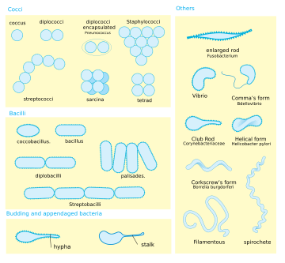in groups of four (**tetracocci**);
* in a cubical arrangement of eight or more (**sarcinae**); in
* irregular clumps resembling bunches of grapes (**staphylococci**, *e.g.,* boil causing bacterium, *Staphylococcus aureus* or in a bead-like chain (**streptococci**, *e.g.,* sore throat causing bacterium, *Streptococcus pyogenes* )

1. **Bacilli** (singular, bacillus).

* These are rod-like bacteria.
* They generally occur singly, but may occasionally be found in pairs (**diplobacilli**) or chains (**streptobacilli**).
* Diseases:
* In Humans:tuberculosis ( *Mycobacterium* or *Bacillus tuberculosis*), tetanus (*Clostridium* *tetani*), typhoid (*Salmonella* or *Bacillus* *typhosus*), diphtheria (*Corynebacterium* *diphtheriae*), leprosy ( *M y c o b a c t e r i u m* *leprae*), dysentery and food poisoning (*Clostridium* *botylinum*).
* In animals are also caused by bacilli, *e.g.,* anthrax (*Bacillus* *anthracis*) and black leg (*Clostridium chauvei*).

1. **Spirilla** ( singular spirillum).

* These are also called **spirochetes**.
* These are spiral- shaped and motile bacteria
* Spirilla cause human disease such as syphilis (*Treponema* *pallidum*).

1. **Vibrios** (singular vibrio).

* These are comma-shaped or bent-rod like bacteria .
* Vibrios cause human disease such as cholera (*Vibrio cholerae*).

1. **Gram negative and Gram positive bacteria.**

Classification based on structure of cell wall and its stainability with the Gram stain

1. Gram Positive b) Gram Negative

Gram staining method: named after **Christian Gram**

Who developed it in Denmark in 1884.

Technique:

* When heat-fixed bacteria are treated with the basic dye, crystal violet, they become blue or purple.
* Such blue stained cells are treated with a mordant (*i.e.,* agent that fixes stains to tissues) such as iodine (*i.e.,* potassium iodide or KI solution) and ultimately washed with some organic solvent such as alcohol. Some bacteria retain the blue colour, while others lose it and stay colourless.
* The former are **Gram positive bacteria** ( *e.g., Bacillus subtilis*, *Staphylococcus*, etc.) and
* The latter are **Gram negative bacteria** (*e.g., Escherichia coli, Simonsiella,* cyanobacteria, etc.). Colourless Gram negative bacteria may thereafter be stained pink with safranin stain for their better microscopic visibility.

**Reason**:

* Cell wall of Gram negative bacteria has high lipid content which tends t be dissolved away by alcohol.
* The alcohol then can enter the cell and leach out the stain,
* Cell walls of Gram positive bacteria form a barrier (*i.e.,* peptidoglycan layers) that prevent the penetration of the solvent inside the cell.

1. **Structure of bacteria.**

Structure with an electron microscope

Components of a typical bacterial cell has:

1. **Outer covering.**

The outer covering of bacterial cell comprises the following three layers:

1. **Plasma membrane.**

* The bacterial protoplast is bound by a living, ultrathin (6 to 8 nm thick) and dynamic plasma membrane.
* The plasma membrane chemically comprises molecules of lipids and proteins which are arranged in a **fluid mosaic pattern**.
* That is, it is composed of a bilayer sheet of **phospholipid** molecules with their polar heads on the surfaces and their fatty-acyl chains (tails) forming the interior.
* The **protein** molecules are embedded within this lipid bilayer, some spanning it, some exist on its inner side and some are located on its external or outer side.
* Functions of membrane proteins:
* the transmembrane proteins act as **carriers** or **permeases** to carry on selective transportation of nutrients (molecules and ions) from the environment to the cell or vice versa.
* Certain proteins of the membrane are involved in oxidative metabolism, *i.e.,* they act as enzymes and carriers for electron flow in respiration and photosynthesis leading to phosphorylation (*i.e.,* conversion of ADP to ATP).
* 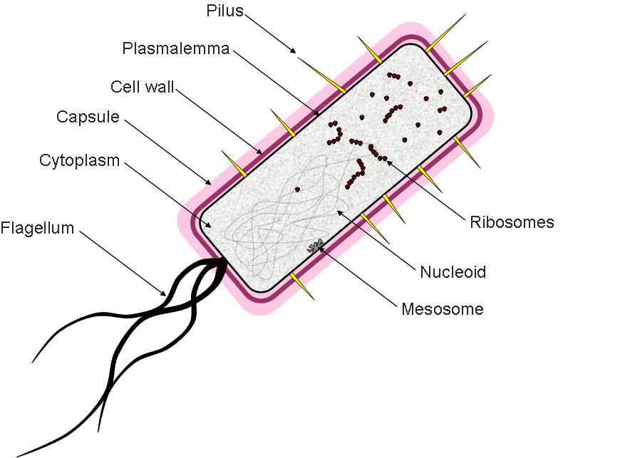The bacterial plasma membrane also provides a specific site at which the single circular chromosome (DNA) remains attached.
* It is the point from where DNA replication starts.
* The first stage in nuclear division involves duplication of this attachment, followed by a progressive bidirectional replication of DNA by two replication forks.

**Plasma membrane intrusions.** Infoldings of the plasma membrane of all Gram-positive bacteria and some Gram-negative bacteria give rise to the following two main types of structures:

1. **Mesosomes** (or **chondrioids**)**.**

* They are extensions of the plasma membrane within the bacterial cell (*i.e.,* cytoplasm) involving complex whorls of convoluted membranes
* Mesosomes tend to increase the plasma membrane’s surface and in turn also increase their enzymatic

contents.

* They are seen in chemoautotrophic bacteria with high rates of aerobic respiration such as

*Nitrosomonas*, and in photosynthetic bacteria such as *Rhodopseudomonas* where they are the site of

photosynthetic pigments.

* Mesosomes are involved in cross-wall (septum) formation during the

division of cell.

1. **Chromatophores.**

* These are photosynthetic pigment-bearing membranous structures of photosynthetic bacteria.
* Chromatophores vary in form as vesicles, tubes, bundled tubes, stacks, or

thylakoids (as in cyanobacteria).

1. **Cell wall.**

* The plasma membrane is covered with a strong and rigid cell wall
* Functions: mechanical protection and provides the bacteria their characteristic shapes ( the cell wall is absent in *Mycoplasma*).
* The cell wall of bacteria differs chemically from the cell wall of plants in that it contains proteins, lipids

and polysaccharides.

* It may also contain chitin but rarely any cellulose.

**Two layers present in cell wall of Gram-negative** **bacteria :**

1. Gel, proteoglycan or peptidoglycan (*e.g.,* murein or muramic acid) containing **periplasmatic space** around the plasma membrane and

2. The **outer** **membrane** which consists of a lipid bilayer traversed by channels of **porin** polypeptide.

* These channels allow diffusion of solutes.
* The lipids of lipid bilayer are phospholipids and lipopolysaccharides (LPS).
* LPS have antigenic property and anchor the proteins and polysaccharides of the surrounding capsule .
* The cell wall of Gram positive bacteria is thicker, amorphous, homogeneous and single layered.
* Chemically it contains many layers of peptidoglycans and proteins, neutral polysaccharides and polyphosphate polymers such as teichoic acids and teichuronic acids.

1. **Capsule.**

* In some bacteria, the cell wall is surrounded by an additional slime or gel layer

called **capsule**.

* Thick, gummy, mucilaginous and is secreted by the plasma membrane.
* Capsule serves mainly as a protective layer against attack by phagocytes and by viruses.
* Helps in regulating the concentration, and uptake of essential ions and water.

1. **Cytoplasm.**

* The plasma membrane encloses a space consisting of **hyaloplasm, matrix** or **cytosol** which is the ground substance and the seat of all metabolic activities.
* **Cmposition of cytosol :**
* Water
* proteins (including multifunctional enzymes),
* lipids,
* carbohydrates,
* different types of RNA molecules,
* and various smaller molecules.
* The cytosol is differentiated into two distinct areas : a less electron dense nuclear area and a very dense area (or dark region).
* In the dense cytoplasm occur thousands of particles, about 25 nm in diameter, called **ribosomes**.
* Ribosomes are composed of ribonucleic acid (RNA) and proteins and they are the sites of protein synthesis.
* Ribosomes of bacteria are 70S type and consist of two subunits (*i.e.*, a larger 50S ribosomal subunit

and a small 30S ribosomal subunit).

* Non-functional ribosomes exist in the form of separated subunits
* which are suspended freely in the cytoplasm.
* During protein synthesis many ribosomes read the codes of single mRNA ( messenger RNA) molecules and form **polyribosomes** or **polysomes**.
* **Reserve materials** of bacteria are stored in the cytoplasm either as finely dispersed or distinct

granules called **inclusion bodies** or **storage granules**.

* Three types of reserve materials.

1. Organic polymers which either serve as reserves of carbon, as does **poly-**↓**-hydroxybutyric**

**acid**, or as stores of energy, as does a polymer of glucose, called **granulose** (*i.e.,* glycogen).

1. Large reserves of inorganic phosphate as highly refractile granules of metaphosphate

polymers known as **volutin**.

1. Elemental **sulphur**, formed by oxidation from hydrogen sulphide. It occurs as an energy reserve in the form of spherical droplets in certain sulphur bacteria.
2. **Nucleoids.**

* In bacteria the nuclear material includes a single, circular and double stranded

DNA molecule which is often called **bacterial chromosome**.

* It is not separated from the cytosol by the nuclear membranes as it occurs in the eukaryotic cells.
* However, the nuclear material is usually concentrated in a specific clear region of the cytoplasm, called **nucleoid**.
* A nucleoid has no ribosome and nucleolus.
* The bacterial chromosome is permanently attached to the plasma membrane at one point, and when isolated often carries a number of membrane component with it.
* Bacterial chromosome does not contain histone proteins, however, chromosomes of some species are found to contain small quantities of a small heat-stable (HU) proteins that may be analogous to eukaryotic histones.
* All three classes of RNA (*i.e.,* mRNA, tRNA, and rRNA) are formed (transcribed) by the activity

of the single RNA polymerase (RNAP) species in prokaryotes.

* The messenger RNA formed at the chromosome is directly available for translation without processing, and so ribosomes may attach to the beginning of the mRNA strand and commence translation, while the other end of the mRNA is still being formed by transcription from DNA.
* Proteins for use within the cell are synthesized at cytoplasmic ribosomes; but ribosomes responsible for the synthesis of membrane proteins or proteins destined for export from the cell to form either the cell wall or secretory products, are attached to the plasma membrane. The resulting exportable polypeptides are ejected directly into or through the membrane as they are formed.
* **Plasmids.** Extrachromosomal genetic elements in the form of small, circular and closed DNA molecules,
* Some plasmids are merely **bacteriophage (viral) DNA** which may alternatively be incorporated within the chromosome.
* Other plasmids may be separated parts of the normal genome from the same or a foreign cell, and may recombine with the main chromosome.
* **Functions:**
* Production of antibiotically active proteins or **colicins** which inhibit the growth of other strains of bacteria in their vicinity (Hence called **colcinogenic factors**) .
* May act as **sex** or **fertility factors** (**F factor**) which stimulate bacterial conjugation.
* **R factors** are also plasmids which carry genes for the resistance to one or more drugs such as chloramphenicol, neomycin, penicillin, streptomyocin, sulphonamides and tetracyclines.

**Flagella and other structures.**

* Many bacteria (*e.g., E. coli*). are motile and contain one or more **flagella** for the cellular locomotion (swimming).
* **Structure:**
* Smaller than the eukaryotic flagella
* 15 to 20 nm in diameter and up to 20 μm long)
* simpler in organization.
* Consists of a helical tube containing a single type of protein subunit, called **flagellin**.
* The flagellum is attached at its base, by a short flexible **hook** that is rotated, like a propeller of ship, by the flagellar rotatory “**motor**” (*i.e.,* basal body).
* The flagellar motor comprises four distinct parts : rotor (M ring), stator, bearing (S ring) and rod.
* The ‘**rotor**’ is a protein disc integrated into the plasma membrane.
* It is driven by energy stored in the transmembrane proton H+ gradient (not by ATP breakdown; see

**Jones**, 1986) and rotates rapidly (~ 100 revolutions/second) in the lipid bilayer against another protein

disc, called the ‘**stator**’.

* A **rod** links the ‘rotor’ to a hook and flagellum, thereby causing them to rotate.
* The protein “**bearing**” serves to seal the outer membrane of the cell wall as the rotating rod passes

through it.

* The `stator’ and `bearing’ remains stationary (**Berg**, 1975; **Adler**, 1976).
* Flagellation patterns: According to the number and arrangement of the flagella in a bacterial cell,

**(1) Monotrichous**. There is a single flagellum at one pole of the cell.

**(2) Lophotrichous**. There are several flagella at one pole.

**(3)** **Amphitrichous**. The cell bears at least one flagellum at each pole.

**(4) Peritrichous**. There are flagella all over the surface of cell (Fig. 3.10).

* Flagella-like **axial filaments** are the characteristics of somespirochetes which move like
* snakes through the environment.
* The axial filaments do not project away from the cell but are wrapped around the cell surface.
* **Fimbriae or pili.**
* Some bacteria (mostly Gram negative bacilli) contain non-flagellar, extremely fine, appendages called **fimbriae** (**Dugid** *et al.,* 1955) or **pili** (singular **pilus**; **Brinton**,1959).
* Pili are non- motile but adhesive structures.
* They enable the bacteria to stick firmly to other bacteria, to a surface or to some eukaryote such as mold, plant and animal cells including red blood cells and epithelial cells of alimentary, respiratory and urinary tracts.
* Pili help in conjugation (*e.g.,* long F-pili or **sex pili** of male bacteria); in the attachment of pathogenic bacteria to their host cells (*e.g.,* attachment of gonorrhea- causing coccus, *Neisseria*

*gonorrhoeae*, to the epithelial cells of the human urinary tract) and in acting as specific

sites of attachment for the bacteriophages.

* Pili are known to be coded by the genes of the plasmid.
* **Spinae.**
* Some Gram positive bacteria have tubular, pericellular and rigid appendages of single protein moiety, called **spinin**.
* They are called **spinae** and are known to help the bacterial cells to tolerate some environmental conditions such as salinity, pH, temperature, etc.
* **Nutrition in bacteria.**
* Wide diversity in their nutrition.
* chemosynthetic,
* photosynthetic,
* but most of them are heterotrophic.
* Either saprophytic or parasitic.
* Parasitic bacteria live on the body of plants and animals and with few exceptions, most bacteria are pathogenic.
* Modes of respiration of bacteria are both aerobic and anaerobic.
* Some of the end products of bacterial anaerobic respiration are useful to man, so, they are used in the manufacture of various foods such as butter, cheese and vinegar.
* *Pseudomonas* is a gram negative heterotrophic aerobic form which can decompose (biodegrade) a wide variety of organic compounds such as hydrocarbons.
* So it is used in reducing water pollution due to petroleum spillage.
* **6. Reproduction in bacteria**.
* Asexually: by **binary fission** and **endospore** formation
* sexually : by **conjugation**.
* **Binary fission:**
* the cell divides into two genetically identical daughter cells.
* The single circular chromosome first makes a copy of itself (*i.e.,* it duplicates) and daughter chromosomes become attached to the plasma membrane.
* They separate as the bacterial cell enlarges and ultimately the formation of a cross wall between the separating daughter chromosomes, divides the parent cell into two daughter cells.
* **Endospore formation:**
* Under unfavourable ecological conditions, many bacteria (*e.g., Clostridium, Bacillus,* etc.) form spores which are not reproductive units but represent an inactive state.
* In endospore formation, a part of the protoplasmic material is used to form an impermeable coat
* or cyst wall around the chromosome along with some cytoplasm.
* The rest of the cell degenerates.
* The spore being metabolically inert can survive an unsuitable temperature, pH and drought.
* Under favourable conditions, spores imbibe water, become metabolically active again and germinate.
* **Conjugation:**
* Bacterial conjugation is simplest form of sexual reproduction known.
* It was first of all observed in *E.coli* by **Laderberg** and **Tatum** in 1946.
* During the process of conjugation, a **F+** or **donor** bacterium (equivalent to male) passes a piece of DNA or plasmid containing **fertility** or **F gene** to the **F ¯**or **recipient** bacterium (equivalent to female).
* The donor’s plasmid passes through the sex pilus of donor cell to the recipient.
* Following the conjugation, the progenies of the recipient express some of the characteristics of the donor.
* Thus, bacterial conjugation is a means of making new genetic combinations or **recombinations** which are expressed in the progeny.

**Examples of Prokaryotic Cells**:

1. **Mycoplasma or PPLO.**

**2. *Escherichia coli***

**3. Cyanobacteria or blue-green algae.**