INTRODUCTION, HISTORY & SCOPE OF GENETICS
INTRODUCTION:
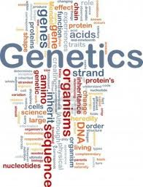
Definition:
Genetics is the study of biologically inherited traits including traits that are influenced in part by environment.
It is derived from a Greek word "gen" which means "to grow into or to become". It is referred as the science of hereditary and variation. Hence it is concerned with transmission, expression and evolution of genes. It is the study of two contradictory aspects of nature:
1. Heredity: It is the process of transmission of characters from one generation to other. Asexual or sexual reproduction is the means for heredity and is the cause of similarities.
2. Variation: It is the cause of difference between the individuals, the differences between brothers and sisters. The science of genetics tends to attempt the mechanism and basis for similarities and differences.
Genomics is the study of all the genes in an organism to understand their molecular organization, function, interaction and evolutionary history.
The fundamental concept of genetics & genomics is that:
"Inherited traits are determined by the elements of heredity that are transmitted from parents to offspring in reproduction; these elements of heredity are called genes."

SCOPE AND APPLICATION OF GENETICS:
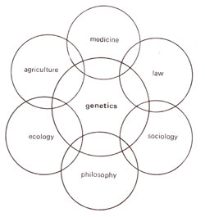Genetics deal not only with the way in which characteristic are transmitted from one generation to the next, but also with how genes bring about the characteristics that they control. Scientist have been using genetics to bring about many changes that benefit human beings.
1. Agriculture and Genetics:
Genetics has many practical applications which are of great value to human beings. In agriculture, for example, knowledge of principles of heredity is very important when it comes to increasing food production. The plant breeders who have been successful in producing superior varieties of food crops that we have a surplus of these crops today. Selective breeding has its benefits. New varieties of crops have been produced which have better yield, better resistance to pests and diseases, and with improved nutritional value. These new varieties have helped increase local food production and cut down food imports.
2. Animals and Genetics:
Many of our domestic animals have been greatly transformed by practical applications of genetic principles such as selective breeding. Selective breeding involves the cross-breeding of two parents, each with some good traits, to produce offspring with the good straits of both parents. Selective breeding in livestock can be carried out by means of artificial insemination, in vitro fertilization and embryo transfer. Through the application of genetics, scientists have been able to produce domestic animals with superior qualities.
3. Forensics and Genetics:
There are even legal applications of the principles of heredity. Court cases involving questions of percentage can be solved by an analysis of blood types and DNA. Crimes have also been solved and suspects been charged or acquitted with the use of DNA testing.
4. Medicines and Genetics:
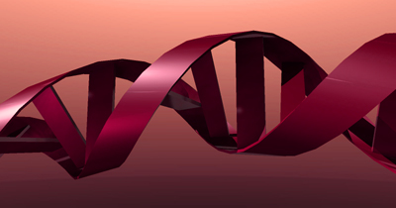In the field of medicine, research has revealed hoe heredity plays a part in many disease. Several serious human diseases, certain of the eye, and disabilities like color blindness and dwarfism are all influenced by heredity. For many disease, an accurate diagnosis can be made more quickly and accurately through a study of one’s family history than through elaborate and expensive laboratory tests. Also, it is possible to avoid many serious mistakes in diagnosis through the application of genetics. Genetics is also important in preventing medicine. In many cases, it is possible to anticipate the development of a disease or other body abnormalities based on family history. Thus, appropriate steps can be taken to prevent its occurrence. A person with a family history of diabetes might be prepared for the onset of the disease and take the necessary steps and precautions to prevent it from getting worse.

5. Biotechnology and Genetics:
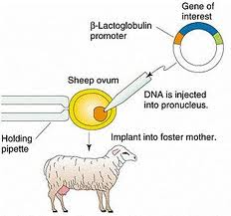In recent years, advances in biotechnology have led to the creation of special genetically engineered strains of bacteria and fungi that carry specific genes from unrelated organisms such as humans. These microbes produce useful compounds as insulin, human growth hormone and agents such as interferon.

