Say you’re stranded on an island. What three things would you want with you?
Got your items? Well done — you’ve just practiced resource management. You have a goal (to survive), and you must decide how to accomplish that goal with as few resources as possible (three items).
In business, however, it’s not always that simple. Resource management requires a thorough understanding of and transparency into your objectives and capacity. By establishing a good process for resource management planning, you’re maximizing efficiency and overseeing the utilization of those resources.

What is resource management?
So what is resource management? Resource management is the process of pre-planning, scheduling, and allocating your resources to maximize efficiency.

Power the Modern, Agile Enterprise
Crush your 2020 goals and keep moving forward with Wrike's work management platform.
Get started for free

A resource is anything that is needed to execute a task or project — this can be the skill sets of employees or the adoption of software. For example, if you’re planning an event, a few resources include scheduling out staff for the event, planning what vendors to use for promotional materials, investing software that allows attendees to register, and budgeting for everything from giveaways to catering.

Why is effective resource management important?
Resource management as part of project management is all about doing more with less. Nobody likes waste, especially in business. Resource management is centered around optimization and efficiency. When you know what you need to make a project successful, you can effectively understand how to plan resources in an efficient way.
To some companies, optimum efficiency is so important that they hire someone solely devoted to resource management; also known as a resource manager. What does a resource manager do? While project managers are responsible for creating and assigning tasks to get the project done, resource managers are accountable for allocating the resources needed to make the project a success.

What are the advantages to resource management?
- Avoids unforeseen hiccups: By understanding your resources upfront and planning how to use them, you can troubleshoot gaps or problems before they happen.
- Prevents burnout: Effective resource management allows you to avoid “overallocation” or “dependency” of resources by gaining insight into your team’s workload.
- Provides a safety net: Let’s say the project was not successful due to lack of resources (it happens). Resource planning and management establishes that you did everything you could with what you had.
- Builds transparency: Other teams can gain visibility into your team’s bandwidth, and plan accordingly if your team is at maximum capacity or available to take on new projects.
- Measures efficiency: With a high-level understanding of what’s needed to manage and execute an upcoming project, you can effectively plan and measure ROI.
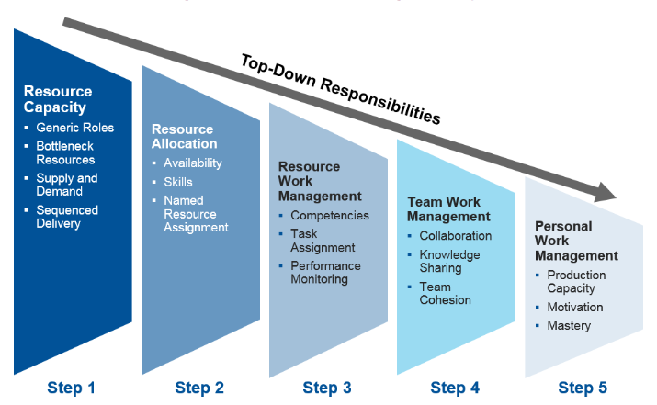Source: Gartner

What are some resource management techniques?
Now that you understand what resource management is, let’s discuss how you can start implementing it across your projects.

1. Resource Allocation
Resource allocation helps you get the most from your available resources. Based on team members’ skills and capacity, resource allocation is the process of tackling projects using the resources you have at your disposal in the most efficient manner possible.
To get a clear view into allocation, project managers will often use resource allocation reports. These can give anywhere from a high-level view to a detailed run down of resource availability — helping you avoid schedule delays and going over budget. The better the reporting capabilities at your disposal, the more transparency and efficiency you will have over your projects.

2. Resource Leveling
Another type of resource management is called resource leveling. This technique aims to discover underused or inefficiently used resources within the organization and work them to your advantage. An example of resource leveling is having a content writer who has experience in graphic design help out the design team by taking on small content tasks that require design work. If a team member can flex their design skills, the design team won’t need to hire a freelancer if they suddenly get flooded with design requests

3. Resource Forecasting
Having a resource management plan is critical to optimizing people, materials, and budget efficiency. Resource forecasting allows you to predict your future resource requirements before a project begins. During the planning stages of a project, you could consider resource management software that forecasts the project’s scope, possible constraints, unforeseen costs, and potential risks.
To make these predictions, project managers must be extremely familiar with the project lifecycle and objectives, and have an overview of available resources within the organization. Project management software provides this level of visibility, as well as easy access to your projects and resources all in one place.

