The leading role of English
Factors which helped English to become the leading language in the world
1.A colonial history:
Pilgrim Fathers landed on Massachusetts coast in 1620 after their journey from Plymouth. British colonialism is a major factor why English became a world wide used language. Pilgrim Fathers brought with them not only a set of religious beliefs, a pioneering spirit and a desire for colonisation but also their language. In 1620 one hundred Puritans boarded the ‘Mayflower’ bound for the New World. These people were the Pilgrim Fathers. The Pilgrim Fathers saw little chance of England becoming a country in which they wished to live. They viewed it as un-Godly and moving from a bad to worse state. The Pilgrim Fathers believed that a new start in the New World was their only chance. Though many years later the Americans broke away from their one-time colonial masters, the language of English remained.
2. Economics:
The spread of global commerce pushed on by the dominant position of the United States. English has become mediating language of international business (example)
3. Information exchange
A great deal of academic discourse around the world takes place in English. The internet has a marked predominence of English. Academic discourse : in international conferences, in journals, scientific articles, in fields such as zoology, chemistry … etc. Airline announcements are in English whatever the language of the country the airport is situated in. English is also the preferred language in air traffic control and is used widely in sea travel communication. The internet had its roots in the USA.
4.Popular culture
Pop music, Films ( in English with subtitles), Slogans / music in advertisements, Brand names ('Red Bull'). In the 'western world' at least, English is dominating language in popular culture. Many people ( pupils) who are not English speakers can sing words from their favourite English songs - even some English Christmas songs have become very popular ( "Jingle Bells"). Cinemagoers frequently hear English on subtitled films. Even in Austrian advertisments you can hear English slogans or songs ( latest example : 'Time stands still' by Anna F. – background music for Raiffeisenbank advertisement. )
The attraction of English and the worldwide motivation for learning English
1.its marketplace value
2.its simplicity in grammatical structure
3.its status
'it pays to learn English' - better job prospects. A basic command is essential for private and professional development and international participation. Simple at least at the elementary level. For many people the use of English is often associated with participation in wealth and progress.
The command of 'basic English' has almost attained the status of a cultural technique like reading and writing ! International language ( used by United Nations). Most often taught as a foreign language. Newspapers , magazines in English available in many countries. Most commonly used language in science. No longer the exclusive cultural property of "native English speakers"
Lingua franca = used between two people who do not share the same language and for whom English is not their mother tongue. It is spoken more among non-native speakers than among native speakers or between native and non-native speakers. It is not directly associated with a country where it is spoken by native speakers. Norms of correct pronunciation , grammar and the meaning of words vary and new varieties of English are appearing
Social class, ethnic groupings and sex affect the language. They influence the way in which listeners judge speakers. Some accents are admired such as 'BBC English' – some have a low status ( e. g. Cockney). There are many other 'inner circle' varieties such as Canadian, Australian , Irish English all of which have their own lexical, grammatical and phonological varieties.
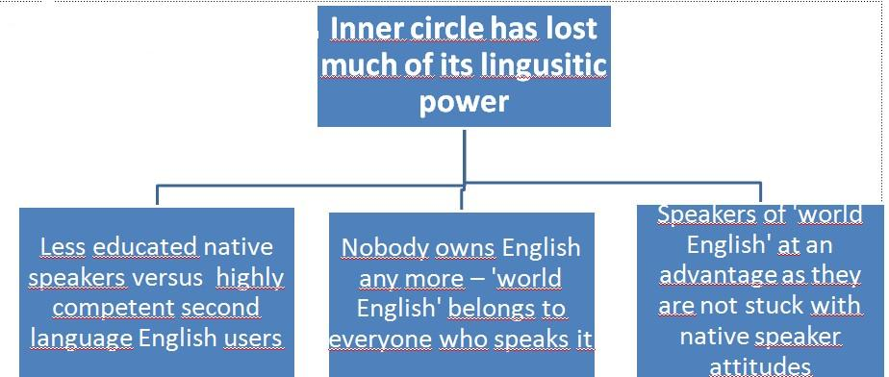

Muharem Špica

