Sidney’s The Defense of Poesy and Renaissance Humanism
Sidney’s Defense of Poesy displays his humanistic education and the humanistic influences in his life. Many times throughout the writ-
ing he adopts the opinions and thoughts of many Greek and Roman philosophers. He stresses how the Greeks and Romans understood and felt about poetry and their influence on the present day sciences and literature. How he pays attention to Greek and Roman thought displays humanistic tendencies. Sidney draws on many pieces of classical literature because of the Renaissance audience. Sidney also states that poetry can be used to assert a certain amount of control over human affairs and that poets are independent thinkers. This shows humanistic aspects because before humanism, people believed that God controlled every aspect of their life and their fate. However, Sidney rejects those tendencies throughout the writing.
“. . . Only the poet, disdaining to be tied to any such subjection, lifted up with the vigor of his own invention, doth grow in effect another nature, in making things either better than nature bringeth forth, or, quite anew, forms such as never were in nature, as the Heroes, Demigods, Cyclops, Chimeras, Furies, and such like: so as he goeth hand in hand with nature, not enclosed within the narrow warrant of her gifts, but freely ranging only within the zodiac of his own wit “(1049-50).
Sidney states that poets are in control of themselves, they are not restricted by outwardly ideas. This sense of individualism was a popular tendency in Renaissance Humanism. Through these main points, it is clear that The Defense of Poesy is written with Humanistic values and ideals.

An Overview of Sidney’s Arguments
In 1579 Stephen Gosson published a short book, The School of Abuse, virtually attacking poets and actors and questioning the morality of fictitious works. These comments while not addressed specifically to Sir Philip Sidney, motivated him to write his own opinions on the subject. In 1580 Sidney wrote The Defense of Poesy also known as An Apology for Poetry. It was not published until 1595. This piece of writing had a huge impact on English Literature and served as one of the first arguments in favor of fiction-making. It spoke to not only the historical relevance of poetry but the practical applications and cultural importance. His reasoning has stood the test of time and is still referred to today when poetry is discussed. Sidney divided his writing into multiple sections to adequately defend poetry’s importance in society. In his opening paragraph he questions why poetry has fallen from the highest estimation of learning to what he calls “the laughingstock of children”.
Historical Importance of Poetry
One of Sidney’s first points is that the majority of our scientists have been Roman and before them Greek, and both of these civilizations placed a great value in the art of poetry. The Romans called poets vates and defined them as a diviner, foreseer, or a prophet. The Greeks named them poet which comes from the word poiein meaning to make. They believed writing poetry to be a divine gift based in God’s ability to create. Sidney writes, “There is no art delivered to mankind that hath not the works of nature for his principal object , without which they could not consist, and on which they so depend, as they become actors and players, as it were, of what nature will have set forth.” He claims that poetry could not exist without nature as inspiration and because nature is a direct result of God’s creativity, poetry has a certain sense of divinity that cannot be ignored.
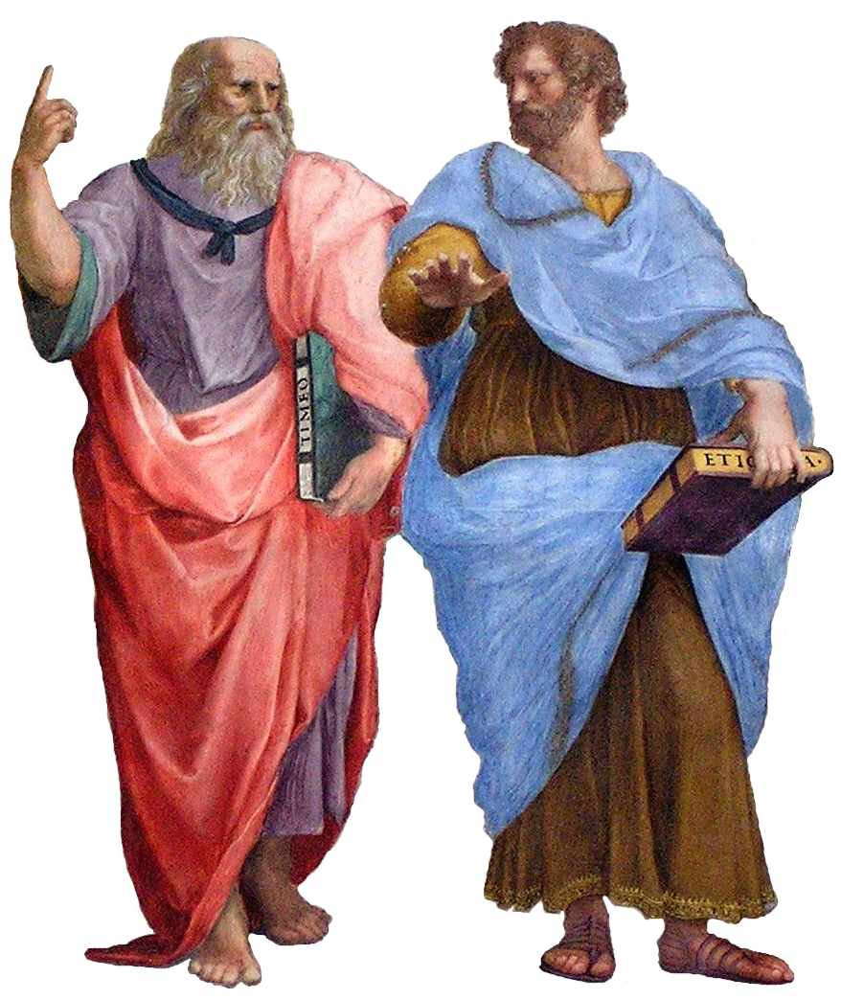
Aristotle and Plato
Definition and Classification of Poetry
Sidney references Aristotle, and the term he used, mimesis which means a representation, counterfeit, or metaphorically, a speaking picture. He writes that although it is possible to view poetry as a simply an unoriginal imitation, on the other hand poets are not limited by the rules of reality. This brings to the forefront the idea that the skill of an artist is based on the idea and not the art itself. For example when a painter uses a model, the end results value is not necessarily a reflection of how closely the piece resembles the original subject. Due to the lack of limitation, poetry has the ability to surpass the beauty of nature. Art is a teaching tool that is also used to delight and entertain. Poetry is divided into many subcategories such as: heroic, lyric, tragic, comic, satiric, iambic, elegiac, and pastoral. He goes on to discuss the importance of verse, however, he is quick to clarify that while verse can be an attribute it is not a necessity. There have been many great poets in history that were not versifiers. For example: Heliodorus in Theagenes and Chariclea which were both written in prose.
Poetry Versus Philosophy and History
One of the most controversial arguments made by Sidney in The Defense of Poesy, was made in this section. Sidney discusses the notion of learning which he defines as a purifying of wit, enrichment of memory, and enlarging of conceit. Some believe the greatest path to happiness is through learning and the gain of knowledge. Those who believed the most important discoveries could be made through the stars gave themselves to the study of Astronomy while others found enlightenment through mathematics, philosophy, and music. Sidney explains this concept writing, “But all, one and other, having this scope: to know, and by knowledge to lift up the mind from the dungeon of the body to the enjoying his own divine essence.” However, he also cautions against immersing oneself too deeply in any individual study using an astronomer whose eyes are constantly trained on the stars falling in a ditch as an example. He advises all those studying any sciences to devote themselves to their passion but also to aim to serve a higher purpose with their discoveries. Just like the saddler aims to make the best saddle but to a further end to improve the horsemanship of a soldier and in turn perfect the art of soldiery.
After these points Sidney continues on to attempt to prove that poets encompass the best traits of Philosophers and Historians. He condemns historians for relying only on the hearsay of others and being trapped in the past instead of looking towards the future. On the other side he complains that philosophers are so busy looking towards the future and pondering the what-ifs that they do not pay attention to the present. His claim is that poets have the ability to remember and paint the past while philosophizing about the future. However, they also have the ability to comprehend the world around them and offer explanations to those experiencing it and assist in making sense of what is happening in the present. Sidney does recognize the importance of both History and Philosophy but maintains that poetry represents an artistic perspective of both.
Answers To Charges Against Poetry
Sidney addresses the accusations that poets are liars or falsifiers by claiming someone cannot lie if they never attempt to tell the truth in the first place. Poetry is not written to record historical details with specific accuracy but rather to speak to the virtue of the person writing and the general feelings of the time. Sidney writes, “To the second, therefore, that they should be the principal liars, I will answer paradoxically, but truly, I think truly, that of all writers under the sun the poet is the least liar, and, though he would, as a poet can scarcely be a liar.” One of the main reasons poetry and fictitious literary works were being condemned was because of the ideology that prophesiers were attempting to be greater than God. England at the time was being overrun with Protestantism, and Sidney used this rational point to help his audience see that was not the purpose of poetry. Once again he mentions Historians and Astronomers. His point being that these studies fall into the category of liars because they seek to affirm knowledge of mankind where a poet makes no attempt to do so.
Conclusion
To conclude his arguments, Sidney summarizes his main points and perspectives. Poetry was never intended to rival the value of other forms of writing and definitely makes no effort to falsify or replace God. While the poet speaks to general truths such as love, family, mortality and nature, they do not try to prove that they are right or affirm their truths. Poetry is a type of literary expression that has lasted the tests of time and will remain a vital art form. Sidney used his defense to claim that poetry has more of a place in society than other sciences and writing styles. This essay has stood the test of time because while he makes valid arguments in a methodical and well-organized way, he also infuses the piece with humor that makes it an easy read. Poetry is an important part of the world and should not be dismissed because of the feelings of society at any given time.

