NITRIFICATION AND DENITRIFICATION
Nitrification
Nitrification plays an important role in the biological water purification in the removal of nitrogen out of the waste water.
Nitrogen occurs in waste water usually as ammonium (NH4+) or bonded in organic compounds. Organically bonded nitrogen is transformed into ammonium when these compounds are depleted by microorganisms. The transformation of ammonium into nitrate (nitrification) occurs by 2 particular bacterial species in particular.
Nitrosomonas spp. provides the first step, the transformation of ammonium to nitrite (NO2)
Nitrobacter spp. provides the second step, the transformation of nitrite to nitrate (NO3-)
The complete equation of the transformation of ammonium to nitrate is:
NH4 + 2O2 -> NO3 + 2H + H2O (water).

Denitrification
In a biological water treatment, denitrification is generally the next step following nitrification. Here nitrate (NO3) and nitrite (NO2) are transformed into nitrogen (N2). The gaseous nitrogen escapes out of the water into the air. Air exists for 78% out of nitrogen (N2) and for 21% out of O2 (oxygen), so N2 is absolutely not polluting the atmosphere.
A large number of aerobic bacteria is able to perform denitrification. When there is no oxygen in the water, these bacteria use nitrate en nitrite as a source of oxygen.

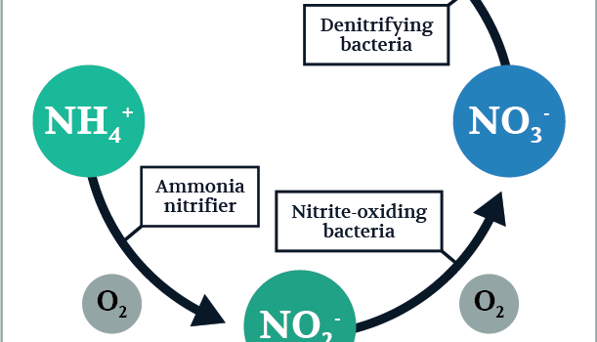
\fig, Difference between Nitrifications; De-nitrification
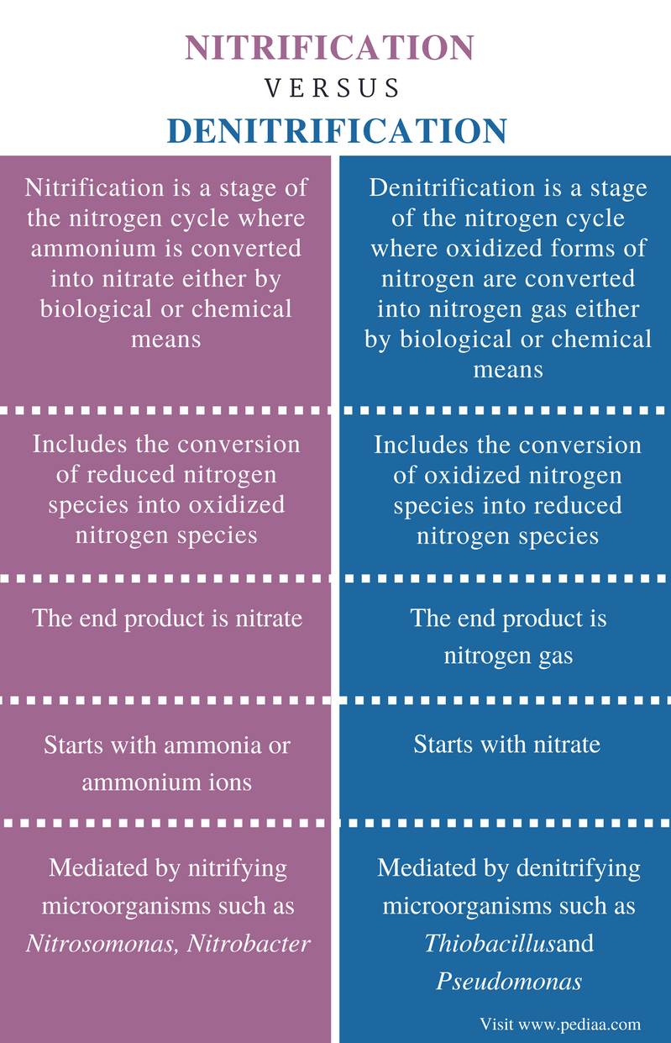

NITROGEN CYCLE
The nitrogen cycle is the biogeochemical cycle by which nitrogen is converted into multiple chemical forms as it circulates among atmosphere, terrestrial, and marine ecosystems. The conversion of nitrogen can be carried out through both biological and physical processes.
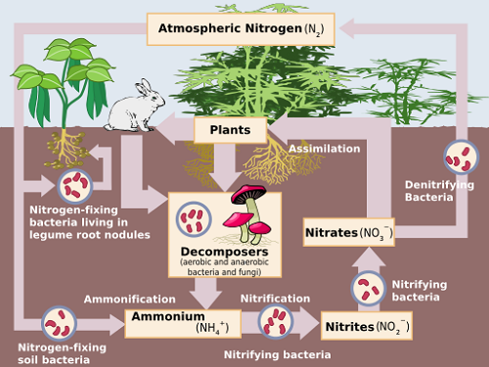
Schematic diagram for Nitrifications De-nitrification
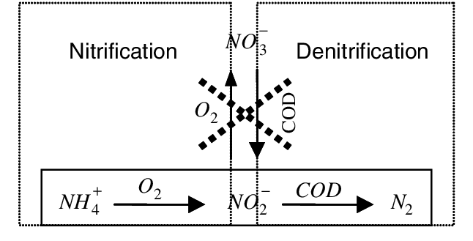
Simple equation for nitrification and denitrification
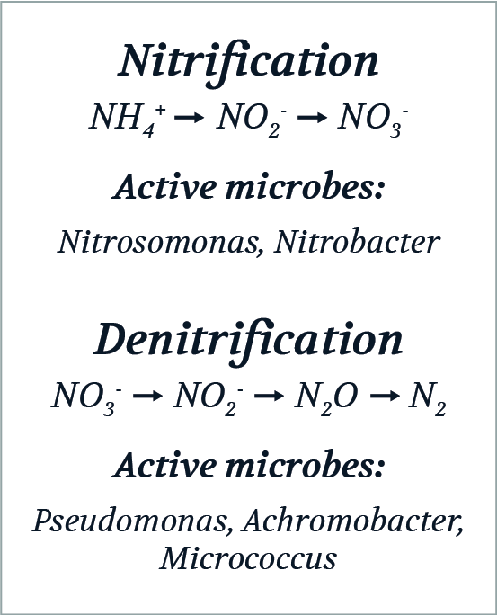
Explain all these figures in simple words

