LEVELS OF GENETICS
Genetic analysis is practiced at different levels. They are:
1. Classical Genetics:
In classical genetic analysis, genes are studied by following the inheritance of traits in crosses between different strains of an organism. It is the oldest type of genetic analysis in which one follows in Mendel's footsteps by focusing on how traits are inherited when different strains of organisms are hybridized.
2. Molecular Genetics:
In molecular genetic analysis, genes are studied by isolating, sequencing and manipulating DNA and by examining the products of gene expression. In this type of genetic analysis one follows the footsteps of Watson and Crick and the army of people who have worked on the various genome projects by focusing on the molecular makeup of the genetic material.
3. Population Genetics:
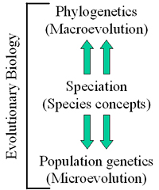In population genetic analysis, genes are studied by assessing the variability among individuals in a group of organisms. This type of genetic analysis imitates Darwin and Wallace by focusing on the entire populations of organisms, hence the biological evolution.

