Introduction to Computers
Processor & Memory
Topics:

- Processor
- Memory
  - Memory types
  - RAM
  - ROM
  - Cache memory
  - Processing with memory
  - Memory units
- Mother Board
- Expansion slots
- Computer Buses
- Ports
- Power supply

- Processor
Processor is another name used for CPU. Alternately referred to as a processor, central processor, or microprocessor. A computer's CPU handles all instructions it receives from hardware and software running on the computer.
A processor, or "microprocessor," is a small chip that resides in computers and other electronic devices. Its basic job is to receive input and provide the appropriate output. While this may seem like a simple task, modern processors can handle trillions of calculations per second.
This processor handles all the basic system instructions, such as processing mouse and keyboard input and running applications.
The picture below is an example of what the top and bottom of a processor may look. The processor is placed and secured into a CPU socket found on the motherboard (we will read in week 4). Processors produce heat, so they are covered with a heat sink (a device to absorb heat) to keep them cool and running smoothly.
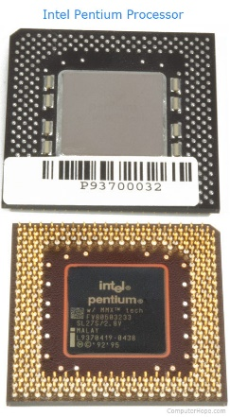
As seen in the picture above, the CPU chip is usually square. On the bottom of the chip are hundreds of connector pins that plug into each of the corresponding holes in the socket. Today, most CPU's resemble the picture shown above.

What does the CPU do?
The CPU's main function is to take input from a peripheral (keyboard, mouse, printer, etc) or computer program, and process what it needs. The CPU then either outputs information to the monitor or performs the peripheral's requested task.

Components of the CPU
In the CPU, there are two primary components.
- ALU (arithmetic logic unit) - performs mathematical, logical (less than, greater then etc.), and decision (true/false) operations.
- CU (control unit) - directs all the processors operations.
- Machine Cycle
The steps performed by the computer processor for each command/instruction received. The machine cycle is a 4 process cycle that includes reading and understanding the machine language, performing the action and then storing the results.
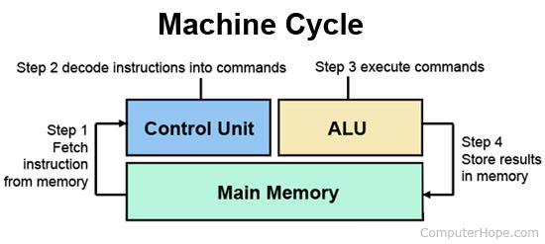
(Main Memory will be discussed in week 4, at the moment, consider it as a storage space where instructions and computer data is stored)

Four steps of machine cycle
- Fetch – Retrieve (get) an instruction from the memory.
- Decode - Translate the retrieved instruction into a series of computer commands (to translate in a language that is understandable by the computer it consists of 1s and 0s and known as binary language). We will be discussing binary language in future lectures.
- Execute - Execute (act on) the computer commands. To perform the instructions.
- Store - Send and write the results back in memory.

- System Clock
The system clock refers to a microchip that controls the timing and speed of all computer functions. In the chip is a crystal that vibrates at a specific frequency when electricity is applied. The speed of a computer processor is measured in clock speed, for example, 1 MHz is one million cycles, or vibrations, a second. 2 GHz is two billion cycles, or vibrations, a second.
A system clock or system timer is a continuous pulse that helps the computer clock keep the correct time. It keeps count of the number of seconds passed and uses that data to calculate the current date and time. It also helps to keep track of and display the time of day on the computer.

2. Memory
A memory is just like a human brain. It is used to store data and instructions. Computer memory is the storage space in the computer, where data is to be processed and instructions required for processing are stored.
Memory is primarily of three types −
- Primary Memory/Main Memory
- Secondary Memory
- Cache Memory
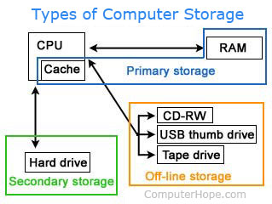

Primary Memory (Main Memory)/Computer Memory
Primary memory holds only those data and instructions on which the computer is currently working. It has a limited capacity and data is lost when power is switched off. It is generally made up of semiconductor device. The data and instruction required to be processed resides in the main memory. It is divided into two subcategories RAM and ROM.
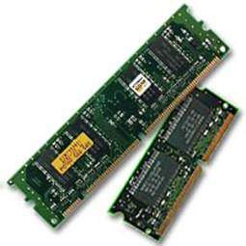

Characteristics of Main Memory
- These are semiconductor memories.
- It is known as the main memory.
- Usually volatile memory (data is lost if computer is turned off).
- Data is lost in case power is switched off.
- It is the working memory of the computer.
- Faster than secondary memories.
- A computer cannot run without the primary memory.

- RAM - Random Access Memory
- The programs and data that the CPU requires during execution of a program are stored in this memory.
- It is a volatile memory as the data loses when the power is turned off.

- ROM - Read Only Memory
- Stores crucial information essential to operate the computer, like the program essential to start the computer.
- It is not volatile.
- Always retains/keeps its data.
- Its data cannot be changed.
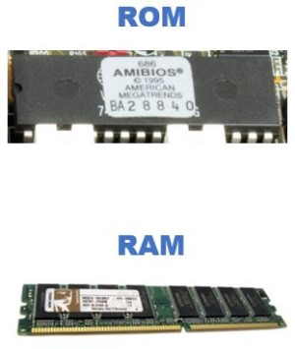

Comparison Chart
 | RAM | ROM
Definition | It is a form of data storage that can be accessed randomly at any time, in any order, allowing quick access and calculations. | It is also a form of data storage that cannot be easily changed. Stores instructions that are necessary for re-booting up to make the computer operate when it is switched off.
Stands for | Random Access Memory | Read-only memory
Use | RAM allows the computer to read data quickly to run applications. It allows reading and writing. | ROM stores the program required to initially boot the computer. It only allows reading.
Volatility | RAM is volatile i.e. its contents are lost when the device is powered off. | It is non-volatile i.e. its contents are retained even when the device is powered off.
Types | The two main types of RAM are static RAM and dynamic RAM. | The types of ROM include PROM, EPROM and EEPROM.

Secondary Memory
This type of memory is also known as external memory or non-volatile. It is slower than the main memory. These are used for storing data/information permanently. CPU directly does not access these memories. The contents of secondary memories are first transferred to the main memory, and then the CPU can access it. For example, hard disk, CD, DVD, USB etc.
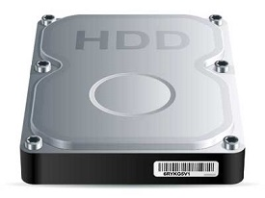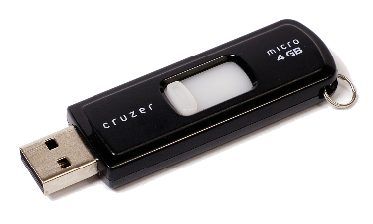

Characteristics of Secondary Memory
- These are magnetic and optical memories.
- It is known as the backup memory.
- It is a non-volatile memory.
- Data is permanently stored even if power is switched off.
- It is used for storage of data in a computer.
- Computer may run without the secondary memory.
- Slower than primary memories.

Cache Memory
Cache memory is a very high speed semiconductor memory which can speed up the CPU. It acts as a buffer between the CPU and the main memory. It is used to hold those parts of data and program which are most frequently used by the CPU. The parts of data and programs are transferred from the disk to cache memory by the operating system (windows), from where the CPU can access them.
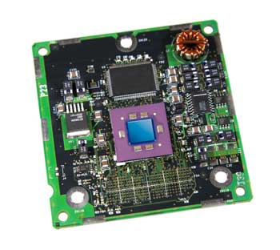

Advantages
The advantages of cache memory are as follows −
- Cache memory is faster than main memory.
- It consumes less access time as compared to main memory.
- It stores the program that can be executed within a short period of time.
- It stores data for temporary use.

Disadvantages
The disadvantages of cache memory are as follows −
- Cache memory has limited capacity.
- It is very expensive.

Why is memory important or needed for a computer?
Each device in a computer operates at different speeds and computer memory gives your computer a place to quickly access data. If the CPU had to wait for a secondary storage device, like a hard disk drive, a computer would be much slower.

Memory Units
Memory unit is the amount of data that can be stored in the storage unit. This storage capacity is expressed in terms of Bytes.
The following table explains the main memory storage units:

Bit (Binary Digit)
A binary digit is a single 0 or single 1. 0 means off and 1 means on. Computer works with electric signals, 0 and 1 represent a passive or an active state of a component in an electric circuit.
1 bit = 1 or 0
Byte
A group of 8 bits is called byte. A byte is the smallest unit, which can represent a data item.
1 byte = 8 bits
1 | Kilobyte (KB)  1 KB = 1024 Bytes
2 | Megabyte (MB)  1 MB = 1024 KB
3 | GigaByte (GB)  1 GB = 1024 MB
4 | TeraByte (TB)  1 TB = 1024 GB
5 | PetaByte (PB)  1 PB = 1024 TB

Mother Board
The motherboard is the main circuit board of your computer and is also known as the mainboard or logic board. If you ever open your computer, the biggest piece of silicon you see is the motherboard. It is a sheet of plastic that holds all the circuitry to connect the various components of a computer system, including the central processing unit (CPU), memory and connectors for input and output devices. In addition to circuits, a motherboard contains a number of sockets and slots to connect the other components.
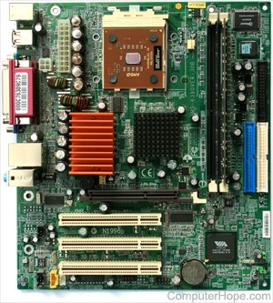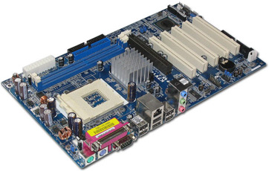
It allocates power and allows communication to and between the CPU, RAM, and all other computer hardware components.

Expansion slots
An expansion slot is a socket on the motherboard that is used to insert an expansion card (or circuit board), which provides additional features to a computer such as video, sound, advanced graphics or RAM. It provides an installation point for a hardware expansion card to be connected. For example, if you wanted to install a new video card in the computer, you'd purchase a video expansion card and install that card into the compatible expansion slot on the motherboard.
Computer Buses
It is a communication system that transfers data between components inside a computer, or between computers.
The bus contains multiple wires (signal lines) that contain addressing information that describes the memory location of where the data is being sent or where it is being retrieved/read. Each wire in the bus carries a single bit of information, which means the more wires a bus has the more information it can address.
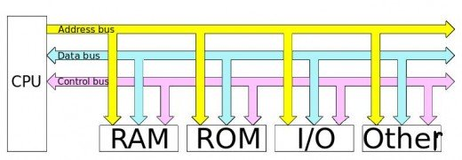

Ports
A port is a hole or connection found on the front or back of a computer. It is a physical connecting point using which an external device can be connected to the computer. A Computer Port is an interface or a point of connection between the computer and its peripheral devices.
The main function of a computer port is to act as a point of attachment, where the cable from the peripheral can be plugged in and allows data to flow from and to the device.

Characteristics of Ports
A port has the following characteristics −
- External devices are connected to a computer using cables and ports.
- Ports are slots on the motherboard into which a cable of external device is plugged in.
- Examples of external devices attached via ports are the mouse, keyboard, monitor, microphone, speakers, USB etc.
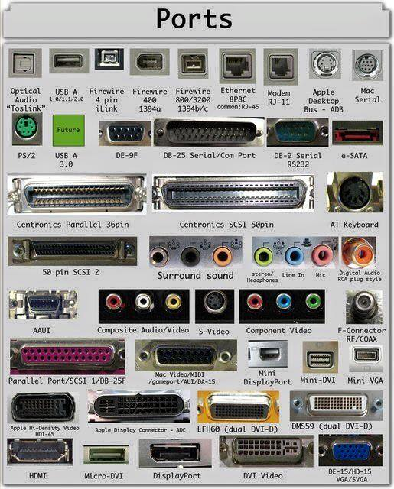

Power supply
Abbreviated as PS or P/S, a power supply or PSU (power supply unit) is a hardware component of a computer that supplies all other components with power. The power supply converts a 110-115 or 220-230 volt AC (alternating current) into a steady low-voltage DC (direct current) usable by the computer.

Everything contained in the computer chassis is powered by the power supply. For example, the motherboard, RAM, CPU, hard drive, disc drives, and most video cards (if the computer has one) are all drawing power from the power supply.

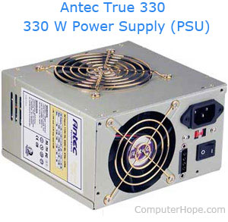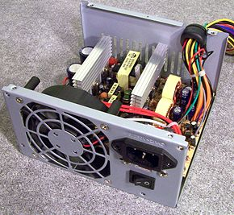

Any other external devices and peripherals, such as the computer monitor and printer, have their own power source. If the computer is a laptop, the display is powered by the computer power supply.
While the computer is on the fan(s) inside a power supply should always be running. If the fan is not running (spinning), either the computer is not working or the fan inside the power supply has failed and the power supply should be replaced.

Inside the Desktop Computer (it is just for your information, just to give you an idea of all the components we discussed above)
The inside of a desktop computer is not as complicated as you may think. Below is an example of the major components that make up inside of a computer.
